Name-Kiran Prakashrao Kadam

Reg no-2019BEC147

Practical-01(ML)

Quation:-

1.Define the multi-dimensional arrays (2x2 and 3x3) using Numpy library and perform various operations on it (addition, subtraction, element-wise multiplication, matrix multiplication) without inbuilt function. Print

The respective outputs.

2.Write a python code to generate dictionary which consist of first 20 natural numbers as a keys. The even number keys must have square of number as value while odd number keys must have cube of number as value. Print the dictionary.

3.Define two variable having functional dependency. Plot the three graphs (simple plot, scatter plot and bar graph) between two variables using Matplotlib library.

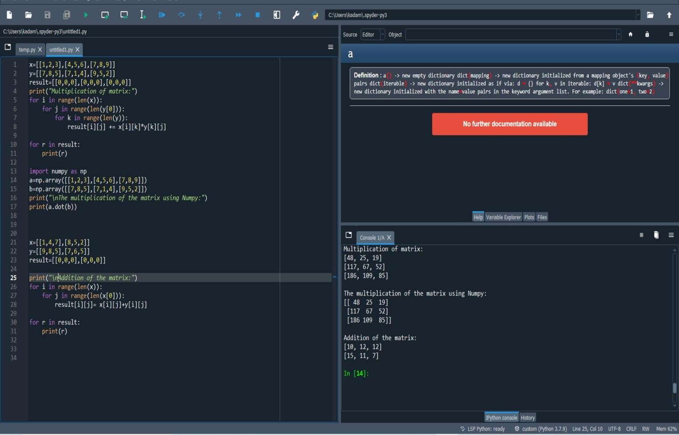

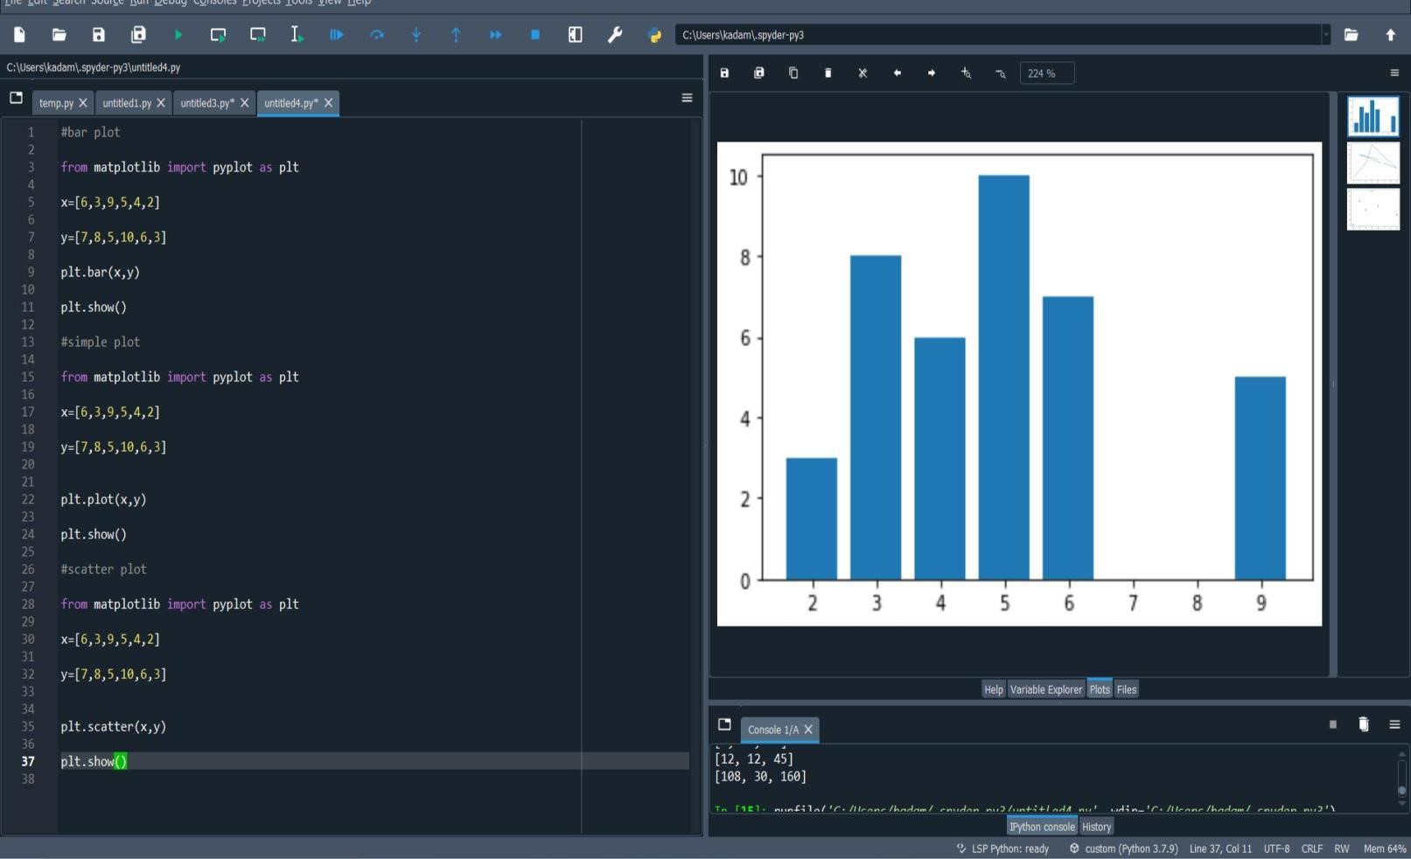

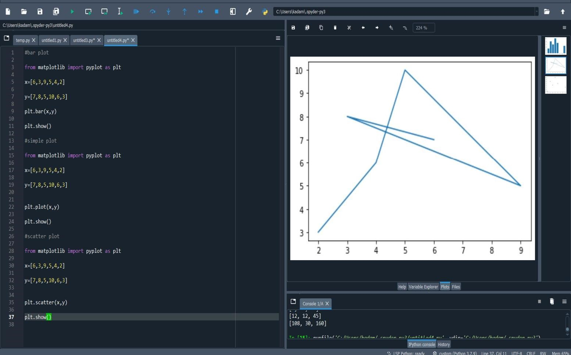

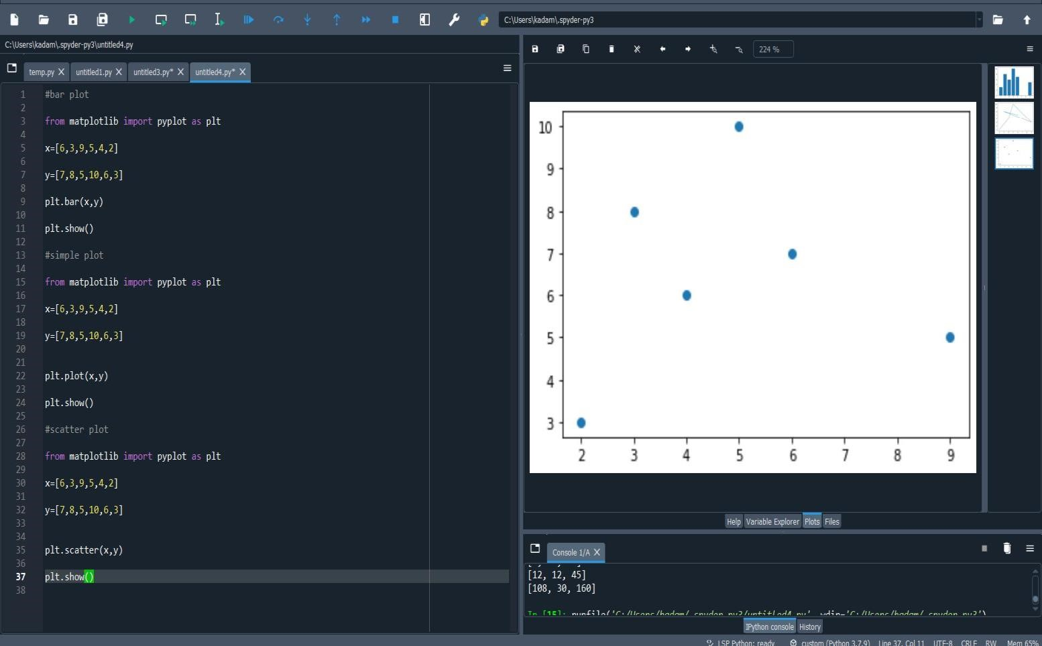

Name: Kiran Prakashrao Kadam

Reg.No:2019BEC147

Roll.NO:A71

In [1]:

*#2d gaussian distribution*

**import**

**numpy**

**as**

**np**

ds

=

np

.

arange

(

-

15

,

7

,

0.03

)

print

(

ds

)

print

(

ds

.

shape

)

mean

=

sum

(

ds

)

/

ds

.

shape

var

=

np

.

var

(

ds

)

print

(

mean

)

print

(

var

)

[-1.50000000e+01 -1.49700000e+01 -1.49400000e+01 -1.49100000e+01

-1.48800000e+01 -1.48500000e+01 -1.48200000e+01 -1.47900000e+01

-1.47600000e+01 -1.47300000e+01 -1.47000000e+01 -1.46700000e+01

-1.46400000e+01 -1.46100000e+01 -1.45800000e+01 -1.45500000e+01

-1.45200000e+01 -1.44900000e+01 -1.44600000e+01 -1.44300000e+01

-1.44000000e+01 -1.43700000e+01 -1.43400000e+01 -1.43100000e+01

-1.42800000e+01 -1.42500000e+01 -1.42200000e+01 -1.41900000e+01

-1.41600000e+01 -1.41300000e+01 -1.41000000e+01 -1.40700000e+01

-1.40400000e+01 -1.40100000e+01 -1.39800000e+01 -1.39500000e+01

-1.39200000e+01 -1.38900000e+01 -1.38600000e+01 -1.38300000e+01

-1.38000000e+01 -1.37700000e+01 -1.37400000e+01 -1.37100000e+01

-1.36800000e+01 -1.36500000e+01 -1.36200000e+01 -1.35900000e+01

-1.35600000e+01 -1.35300000e+01 -1.35000000e+01 -1.34700000e+01

-1.34400000e+01 -1.34100000e+01 -1.33800000e+01 -1.33500000e+01

-1.33200000e+01 -1.32900000e+01 -1.32600000e+01 -1.32300000e+01

-1.32000000e+01 -1.31700000e+01 -1.31400000e+01 -1.31100000e+01

-1.30800000e+01 -1.30500000e+01 -1.30200000e+01 -1.29900000e+01

-1.29600000e+01 -1.29300000e+01 -1.29000000e+01 -1.28700000e+01

-1.28400000e+01 -1.28100000e+01 -1.27800000e+01 -1.27500000e+01

-1.27200000e+01 -1.26900000e+01 -1.26600000e+01 -1.26300000e+01

-1.26000000e+01 -1.25700000e+01 -1.25400000e+01 -1.25100000e+01

-1.24800000e+01 -1.24500000e+01 -1.24200000e+01 -1.23900000e+01

-1.23600000e+01 -1.23300000e+01 -1.23000000e+01 -1.22700000e+01

-1.22400000e+01 -1.22100000e+01 -1.21800000e+01 -1.21500000e+01

-1.21200000e+01 -1.20900000e+01 -1.20600000e+01 -1.20300000e+01

-1.20000000e+01 -1.19700000e+01 -1.19400000e+01 -1.19100000e+01

-1.18800000e+01 -1.18500000e+01 -1.18200000e+01 -1.17900000e+01

-1.17600000e+01 -1.17300000e+01 -1.17000000e+01 -1.16700000e+01

-1.16400000e+01 -1.16100000e+01 -1.15800000e+01 -1.15500000e+01

-1.15200000e+01 -1.14900000e+01 -1.14600000e+01 -1.14300000e+01

-1.14000000e+01 -1.13700000e+01 -1.13400000e+01 -1.13100000e+01

-1.12800000e+01 -1.12500000e+01 -1.12200000e+01 -1.11900000e+01

-1.11600000e+01 -1.11300000e+01 -1.11000000e+01 -1.10700000e+01

-1.10400000e+01 -1.10100000e+01 -1.09800000e+01 -1.09500000e+01

-1.09200000e+01 -1.08900000e+01 -1.08600000e+01 -1.08300000e+01

-1.08000000e+01 -1.07700000e+01 -1.07400000e+01 -1.07100000e+01

-1.06800000e+01 -1.06500000e+01 -1.06200000e+01 -1.05900000e+01

-1.05600000e+01 -1.05300000e+01 -1.05000000e+01 -1.04700000e+01

-1.04400000e+01 -1.04100000e+01 -1.03800000e+01 -1.03500000e+01

-1.03200000e+01 -1.02900000e+01 -1.02600000e+01 -1.02300000e+01

-1.02000000e+01 -1.01700000e+01 -1.01400000e+01 -1.01100000e+01

-1.00800000e+01 -1.00500000e+01 -1.00200000e+01 -9.99000000e+00

-9.96000000e+00 -9.93000000e+00 -9.90000000e+00 -9.87000000e+00

-9.84000000e+00 -9.81000000e+00 -9.78000000e+00 -9.75000000e+00

-9.72000000e+00 -9.69000000e+00 -9.66000000e+00 -9.63000000e+00

-9.60000000e+00 -9.57000000e+00 -9.54000000e+00 -9.51000000e+00

-9.48000000e+00 -9.45000000e+00 -9.42000000e+00 -9.39000000e+00

-9.36000000e+00 -9.33000000e+00 -9.30000000e+00 -9.27000000e+00

-9.24000000e+00 -9.21000000e+00 -9.18000000e+00 -9.15000000e+00

-9.12000000e+00 -9.09000000e+00 -9.06000000e+00 -9.03000000e+00

-9.00000000e+00 -8.97000000e+00 -8.94000000e+00 -8.91000000e+00

-8.88000000e+00 -8.85000000e+00 -8.82000000e+00 -8.79000000e+00

-8.76000000e+00 -8.73000000e+00 -8.70000000e+00 -8.67000000e+00

-8.64000000e+00 -8.61000000e+00 -8.58000000e+00 -8.55000000e+00

-8.52000000e+00 -8.49000000e+00 -8.46000000e+00 -8.43000000e+00

-8.40000000e+00 -8.37000000e+00 -8.34000000e+00 -8.31000000e+00

-8.28000000e+00 -8.25000000e+00 -8.22000000e+00 -8.19000000e+00

-8.16000000e+00 -8.13000000e+00 -8.10000000e+00 -8.07000000e+00

-8.04000000e+00 -8.01000000e+00 -7.98000000e+00 -7.95000000e+00 -7.92000000e+00 -7.89000000e+00 -7.86000000e+00 -7.83000000e+00

-7.80000000e+00 -7.77000000e+00 -7.74000000e+00 -7.71000000e+00

-7.68000000e+00 -7.65000000e+00 -7.62000000e+00 -7.59000000e+00

-7.56000000e+00 -7.53000000e+00 -7.50000000e+00 -7.47000000e+00

-7.44000000e+00 -7.41000000e+00 -7.38000000e+00 -7.35000000e+00

-7.32000000e+00 -7.29000000e+00 -7.26000000e+00 -7.23000000e+00

-7.20000000e+00 -7.17000000e+00 -7.14000000e+00 -7.11000000e+00

-7.08000000e+00 -7.05000000e+00 -7.02000000e+00 -6.99000000e+00

-6.96000000e+00 -6.93000000e+00 -6.90000000e+00 -6.87000000e+00

-6.84000000e+00 -6.81000000e+00 -6.78000000e+00 -6.75000000e+00

-6.72000000e+00 -6.69000000e+00 -6.66000000e+00 -6.63000000e+00

-6.60000000e+00 -6.57000000e+00 -6.54000000e+00 -6.51000000e+00

-6.48000000e+00 -6.45000000e+00 -6.42000000e+00 -6.39000000e+00

-6.36000000e+00 -6.33000000e+00 -6.30000000e+00 -6.27000000e+00

-6.24000000e+00 -6.21000000e+00 -6.18000000e+00 -6.15000000e+00

-6.12000000e+00 -6.09000000e+00 -6.06000000e+00 -6.03000000e+00

-6.00000000e+00 -5.97000000e+00 -5.94000000e+00 -5.91000000e+00

-5.88000000e+00 -5.85000000e+00 -5.82000000e+00 -5.79000000e+00

-5.76000000e+00 -5.73000000e+00 -5.70000000e+00 -5.67000000e+00

-5.64000000e+00 -5.61000000e+00 -5.58000000e+00 -5.55000000e+00

-5.52000000e+00 -5.49000000e+00 -5.46000000e+00 -5.43000000e+00

-5.40000000e+00 -5.37000000e+00 -5.34000000e+00 -5.31000000e+00

-5.28000000e+00 -5.25000000e+00 -5.22000000e+00 -5.19000000e+00

-5.16000000e+00 -5.13000000e+00 -5.10000000e+00 -5.07000000e+00

-5.04000000e+00 -5.01000000e+00 -4.98000000e+00 -4.95000000e+00

-4.92000000e+00 -4.89000000e+00 -4.86000000e+00 -4.83000000e+00

-4.80000000e+00 -4.77000000e+00 -4.74000000e+00 -4.71000000e+00

-4.68000000e+00 -4.65000000e+00 -4.62000000e+00 -4.59000000e+00

-4.56000000e+00 -4.53000000e+00 -4.50000000e+00 -4.47000000e+00

-4.44000000e+00 -4.41000000e+00 -4.38000000e+00 -4.35000000e+00

-4.32000000e+00 -4.29000000e+00 -4.26000000e+00 -4.23000000e+00

-4.20000000e+00 -4.17000000e+00 -4.14000000e+00 -4.11000000e+00

-4.08000000e+00 -4.05000000e+00 -4.02000000e+00 -3.99000000e+00

-3.96000000e+00 -3.93000000e+00 -3.90000000e+00 -3.87000000e+00

-3.84000000e+00 -3.81000000e+00 -3.78000000e+00 -3.75000000e+00

-3.72000000e+00 -3.69000000e+00 -3.66000000e+00 -3.63000000e+00

-3.60000000e+00 -3.57000000e+00 -3.54000000e+00 -3.51000000e+00

-3.48000000e+00 -3.45000000e+00 -3.42000000e+00 -3.39000000e+00

-3.36000000e+00 -3.33000000e+00 -3.30000000e+00 -3.27000000e+00

-3.24000000e+00 -3.21000000e+00 -3.18000000e+00 -3.15000000e+00

-3.12000000e+00 -3.09000000e+00 -3.06000000e+00 -3.03000000e+00

-3.00000000e+00 -2.97000000e+00 -2.94000000e+00 -2.91000000e+00

-2.88000000e+00 -2.85000000e+00 -2.82000000e+00 -2.79000000e+00

-2.76000000e+00 -2.73000000e+00 -2.70000000e+00 -2.67000000e+00

-2.64000000e+00 -2.61000000e+00 -2.58000000e+00 -2.55000000e+00

-2.52000000e+00 -2.49000000e+00 -2.46000000e+00 -2.43000000e+00

-2.40000000e+00 -2.37000000e+00 -2.34000000e+00 -2.31000000e+00

-2.28000000e+00 -2.25000000e+00 -2.22000000e+00 -2.19000000e+00

-2.16000000e+00 -2.13000000e+00 -2.10000000e+00 -2.07000000e+00

-2.04000000e+00 -2.01000000e+00 -1.98000000e+00 -1.95000000e+00

-1.92000000e+00 -1.89000000e+00 -1.86000000e+00 -1.83000000e+00

-1.80000000e+00 -1.77000000e+00 -1.74000000e+00 -1.71000000e+00

-1.68000000e+00 -1.65000000e+00 -1.62000000e+00 -1.59000000e+00

-1.56000000e+00 -1.53000000e+00 -1.50000000e+00 -1.47000000e+00

-1.44000000e+00 -1.41000000e+00 -1.38000000e+00 -1.35000000e+00

-1.32000000e+00 -1.29000000e+00 -1.26000000e+00 -1.23000000e+00

-1.20000000e+00 -1.17000000e+00 -1.14000000e+00 -1.11000000e+00

-1.08000000e+00 -1.05000000e+00 -1.02000000e+00 -9.90000000e-01

-9.60000000e-01 -9.30000000e-01 -9.00000000e-01 -8.70000000e-01 -8.40000000e-01 -8.10000000e-01 -7.80000000e-01 -7.50000000e-01

-7.20000000e-01 -6.90000000e-01 -6.60000000e-01 -6.30000000e-01

-6.00000000e-01 -5.70000000e-01 -5.40000000e-01 -5.10000000e-01

-4.80000000e-01 -4.50000000e-01 -4.20000000e-01 -3.90000000e-01

-3.60000000e-01 -3.30000000e-01 -3.00000000e-01 -2.70000000e-01

-2.40000000e-01 -2.10000000e-01 -1.80000000e-01 -1.50000000e-01

-1.20000000e-01 -9.00000000e-02 -6.00000000e-02 -3.00000000e-02

-3.19744231e-13 3.00000000e-02 6.00000000e-02 9.00000000e-02

1.20000000e-01 1.50000000e-01 1.80000000e-01 2.10000000e-01

2.40000000e-01 2.70000000e-01 3.00000000e-01 3.30000000e-01 3.60000000e-01 3.90000000e-01 4.20000000e-01 4.50000000e-01 4.80000000e-01 5.10000000e-01 5.40000000e-01 5.70000000e-01 6.00000000e-01 6.30000000e-01 6.60000000e-01 6.90000000e-01 7.20000000e-01 7.50000000e-01 7.80000000e-01 8.10000000e-01 8.40000000e-01 8.70000000e-01 9.00000000e-01 9.30000000e-01 9.60000000e-01 9.90000000e-01 1.02000000e+00 1.05000000e+00 1.08000000e+00 1.11000000e+00 1.14000000e+00 1.17000000e+00 1.20000000e+00 1.23000000e+00 1.26000000e+00 1.29000000e+00 1.32000000e+00 1.35000000e+00 1.38000000e+00 1.41000000e+00 1.44000000e+00 1.47000000e+00 1.50000000e+00 1.53000000e+00 1.56000000e+00 1.59000000e+00 1.62000000e+00 1.65000000e+00 1.68000000e+00 1.71000000e+00 1.74000000e+00 1.77000000e+00 1.80000000e+00 1.83000000e+00 1.86000000e+00 1.89000000e+00 1.92000000e+00 1.95000000e+00 1.98000000e+00 2.01000000e+00 2.04000000e+00 2.07000000e+00 2.10000000e+00 2.13000000e+00 2.16000000e+00 2.19000000e+00 2.22000000e+00 2.25000000e+00 2.28000000e+00 2.31000000e+00 2.34000000e+00 2.37000000e+00 2.40000000e+00 2.43000000e+00 2.46000000e+00 2.49000000e+00 2.52000000e+00 2.55000000e+00 2.58000000e+00 2.61000000e+00 2.64000000e+00 2.67000000e+00 2.70000000e+00 2.73000000e+00 2.76000000e+00 2.79000000e+00 2.82000000e+00 2.85000000e+00 2.88000000e+00 2.91000000e+00 2.94000000e+00 2.97000000e+00 3.00000000e+00 3.03000000e+00 3.06000000e+00 3.09000000e+00 3.12000000e+00 3.15000000e+00 3.18000000e+00 3.21000000e+00 3.24000000e+00 3.27000000e+00 3.30000000e+00 3.33000000e+00 3.36000000e+00 3.39000000e+00 3.42000000e+00 3.45000000e+00 3.48000000e+00 3.51000000e+00 3.54000000e+00 3.57000000e+00 3.60000000e+00 3.63000000e+00 3.66000000e+00 3.69000000e+00 3.72000000e+00 3.75000000e+00 3.78000000e+00 3.81000000e+00 3.84000000e+00 3.87000000e+00 3.90000000e+00 3.93000000e+00 3.96000000e+00 3.99000000e+00 4.02000000e+00 4.05000000e+00 4.08000000e+00 4.11000000e+00 4.14000000e+00 4.17000000e+00 4.20000000e+00 4.23000000e+00 4.26000000e+00 4.29000000e+00 4.32000000e+00 4.35000000e+00 4.38000000e+00 4.41000000e+00 4.44000000e+00 4.47000000e+00 4.50000000e+00 4.53000000e+00 4.56000000e+00 4.59000000e+00 4.62000000e+00 4.65000000e+00 4.68000000e+00 4.71000000e+00 4.74000000e+00 4.77000000e+00 4.80000000e+00 4.83000000e+00 4.86000000e+00 4.89000000e+00 4.92000000e+00 4.95000000e+00 4.98000000e+00 5.01000000e+00 5.04000000e+00 5.07000000e+00 5.10000000e+00 5.13000000e+00 5.16000000e+00 5.19000000e+00 5.22000000e+00 5.25000000e+00 5.28000000e+00 5.31000000e+00 5.34000000e+00 5.37000000e+00 5.40000000e+00 5.43000000e+00 5.46000000e+00 5.49000000e+00 5.52000000e+00 5.55000000e+00 5.58000000e+00 5.61000000e+00 5.64000000e+00 5.67000000e+00 5.70000000e+00 5.73000000e+00 5.76000000e+00 5.79000000e+00 5.82000000e+00 5.85000000e+00 5.88000000e+00 5.91000000e+00 5.94000000e+00 5.97000000e+00 6.00000000e+00 6.03000000e+00 6.06000000e+00 6.09000000e+00 6.12000000e+00 6.15000000e+00 6.18000000e+00 6.21000000e+00 6.24000000e+00 6.27000000e+00 6.30000000e+00 6.33000000e+00

6.36000000e+00 6.39000000e+00 6.42000000e+00 6.45000000e+00

6.48000000e+00 6.51000000e+00 6.54000000e+00 6.57000000e+00

6.60000000e+00 6.63000000e+00 6.66000000e+00 6.69000000e+00

6.72000000e+00 6.75000000e+00 6.78000000e+00 6.81000000e+00

6.84000000e+00 6.87000000e+00 6.90000000e+00 6.93000000e+00

6.96000000e+00 6.99000000e+00] (734,)

[-4.005]

40.40662499999827 In

[2]:

**def**

gauss_dis_2d

(

data_samples

,

mean

,

var

):

gd

=

np

.

zeros

(

len

(

data_samples

))

**for**

i

**in**

range

(

len

(

data_samples

)):

gd

[

i

]

=

np

.

exp

(

-

0.5

*

(

data_samples

[

i

]

-

mean

)

**

2

/

(

2

*

var

**

2

)

/

np

.

sqrt

(

2

*

np

.

pi

*

var

**

2

))

**return**

gd

In [3]:

**from**

**matplotlib**

**import**

pyplot

**as**

plt

my_gd1

=

gauss_dis_2d

(

ds

,

mean

,

var

)

plt

.

plot

(

ds

,

my_gd1

)

Out[3]:

[<matplotlib.lines.Line2D at 0x17bf5848700>]

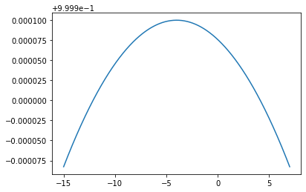

0x17bf58bf5b0>]

[4]:

*#fixing mean varing variance*

var1

=

1

my_gd2

=

gauss_dis_2d

(

ds

,

mean

,

var1

)

plt

.

plot

(

ds

,

my_gd2

)

Out[4]:

[<

matplotlib.lines.Line2D at

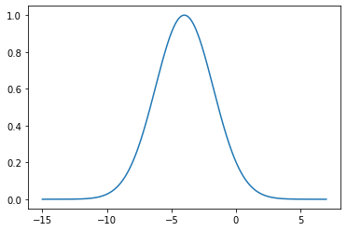

In [5]:

*#fixing variance varing mean*

mean

=-

5

my_gd3

=

gauss_dis_2d

(

ds

,

mean

,

var

)

plt

.

plot

(

ds

,

my_gd3

)

Out[5]:

[<matplotlib.lines.Line2D at 0x17bf59394c0>]

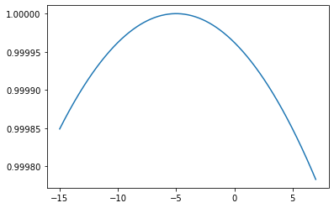

[7]:

*#taking mean and variance from user*

mean

=

int

(

input

(

'Enter mean ='

))

var

=

int

(

input

(

'Enter variance ='

))

my_gd4

=

gauss_dis_2d

(

ds

,

mean

,

var

)

plt

.

plot

(

ds

,

my_gd4

)

Enter mean =-1 Enter

variance =5 Out[7]: [<matplotlib.lines.Line2D at

0x17bf59e7520>]

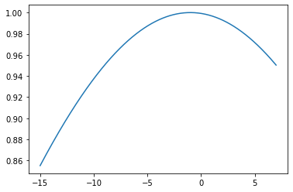

In [8]:

*#3d gaussian distrubition*

X1

=

np

.

linspace

(

-

4

,

4

,

10

)

X2

=

np

.

linspace

(

-

8

,

3

,

20

)

x1

,

x2

=

np

.

meshgrid

(

X1

,

X2

)

print

(

x1

.

shape

)

print

(

x2

.

shape

)

(20

, 10)

(20, 10) [9]:

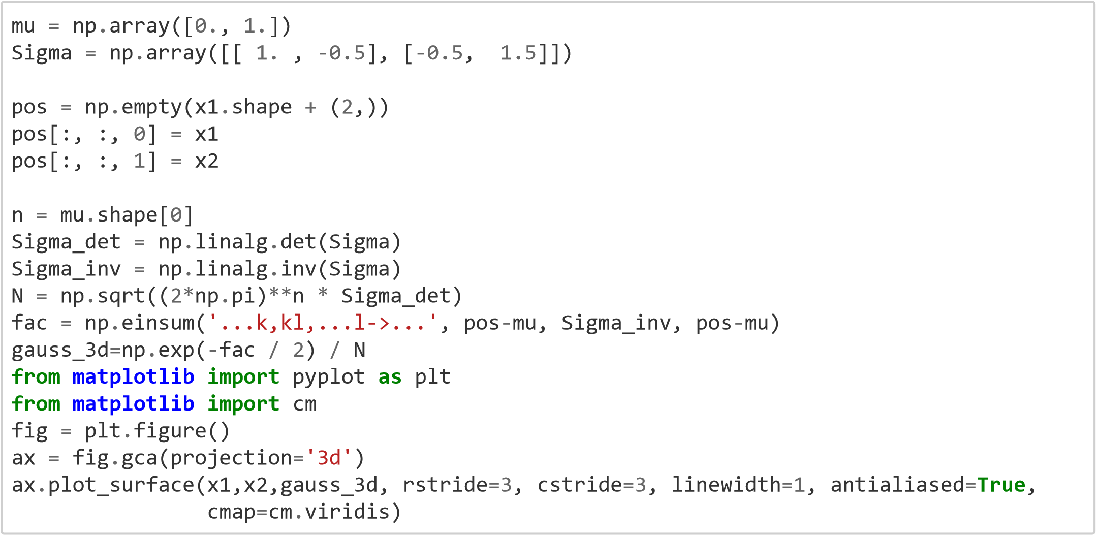

Out[9]: <mpl_toolkits.mplot3d.art3d.Poly3DCollection at

0x17bf58a0220>

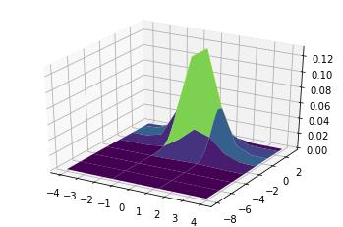

In [10]:

*#function* **def** gauss_dis_3d(pos,mean1,mean2,sigma1,sigma2,sigma3,sigma4):

mu = np.array([0., 1.])

Sigma = np.array([[ 1. , -0.5], [-0.5, 1.5]]) n = mu.shape[0]

Sigma_det = np.linalg.det(Sigma)

Sigma_inv = np.linalg.inv(Sigma) N

= np.sqrt((2*np.pi)**n * Sigma_det) fac = np.einsum('...k,kl,...l->...', pos-mu, Sigma_inv, pos-mu) **return** np.exp(-fac / 2) / N

[11]:

mean1 = float(input('enter mean1:')) mean2 = float(input('enter mean2:')) sigma1 = float(input('enter sigma1:')) sigma2 = float(input('enter sigma2:')) sigma3 =

sigma2:-0.25 enter sigma3:-0.25 enter sigma4:1.

Out[11]:

<mpl_toolkits.mplot3d.art3d.Poly3DCollection at 0x17bf5f27a00>

1

/31/22, 4:05 AM

Practical 2

In

float

(

input

(

'enter sigma3:'

))

sigma4

=

float

(

input

(

'enter sigma4:'

))

gauss_3d

=

gauss_dis_3d(pos,mean1,mean2,sigma1,sigma2,sigma3,sigma4)

**from**

**matplotlib**

**import**

pyplot

**as**

plt

**from**

**matplotlib**

**import**

cm fig

=

plt

.

figure() ax

=

fig

.

gca(projection

=

'3d'

)

ax

.

plot_surface(x1,x2,gauss_3d, rstride

=3

, cstride

=3

, linewidth

=1

, antialiased

=

**True**

,

cmap

=

cm

.

viridis)

enter mean1:0.5 enter

mean2:0.75 enter

sigma1:0.75 enter



Conclusion: In the given practical we plot 2d and 3d Gaussian distribution curve using probability of likelihood formula.From the graphs we can conclude that the peak of curve depends on mean value and the width of the curve depend on variance.

Kiran Prakashrao Kadam Reg:-2019BEC147 Practical:-03

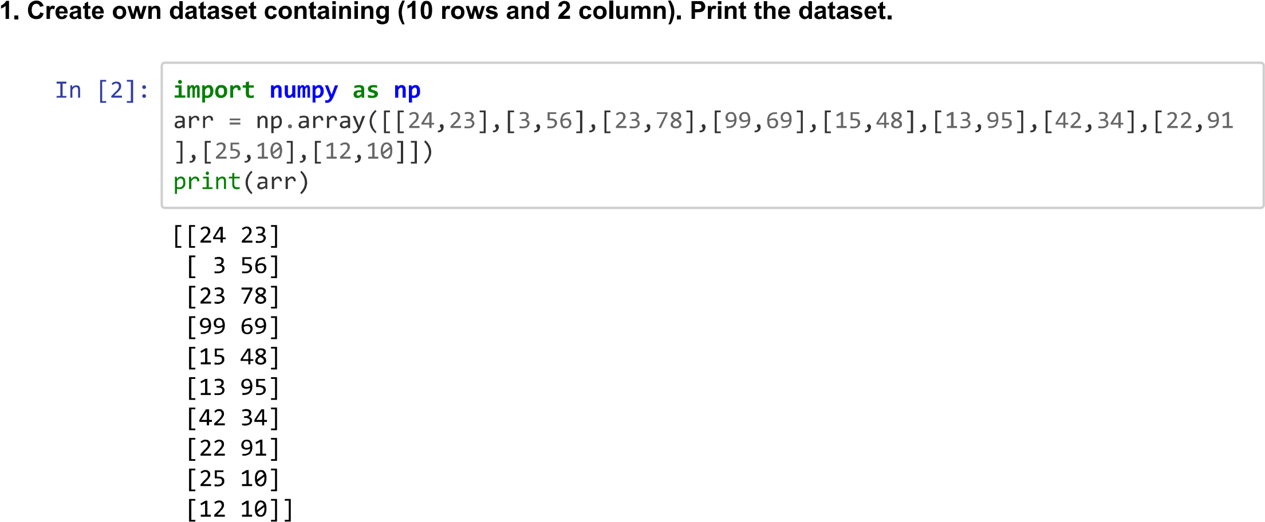



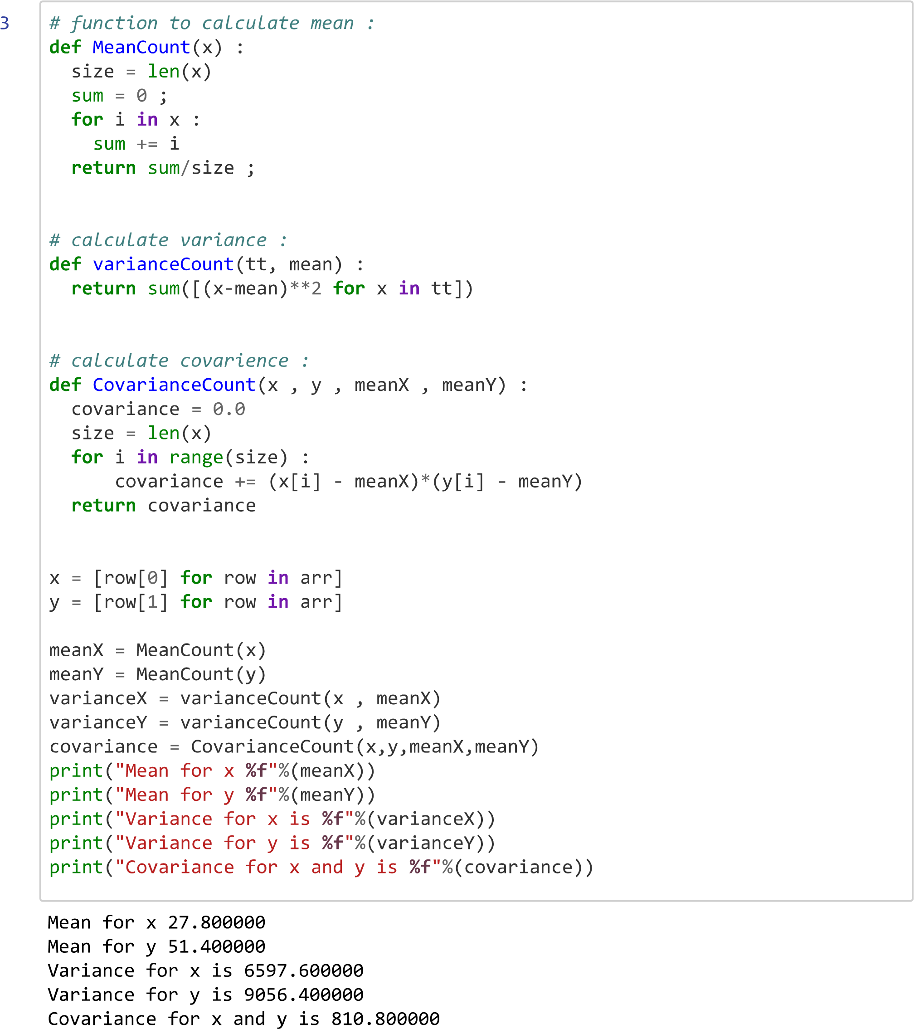

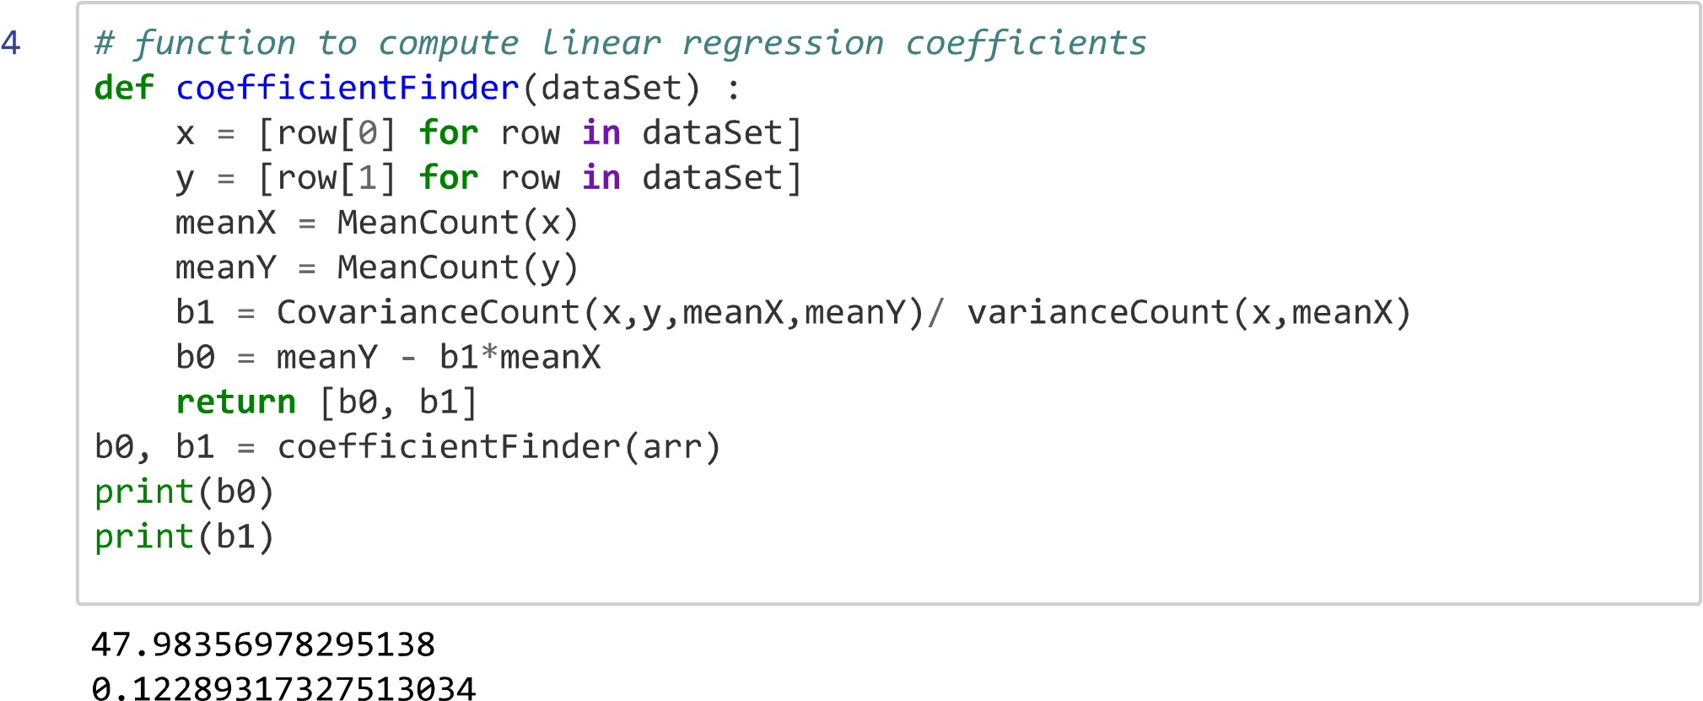

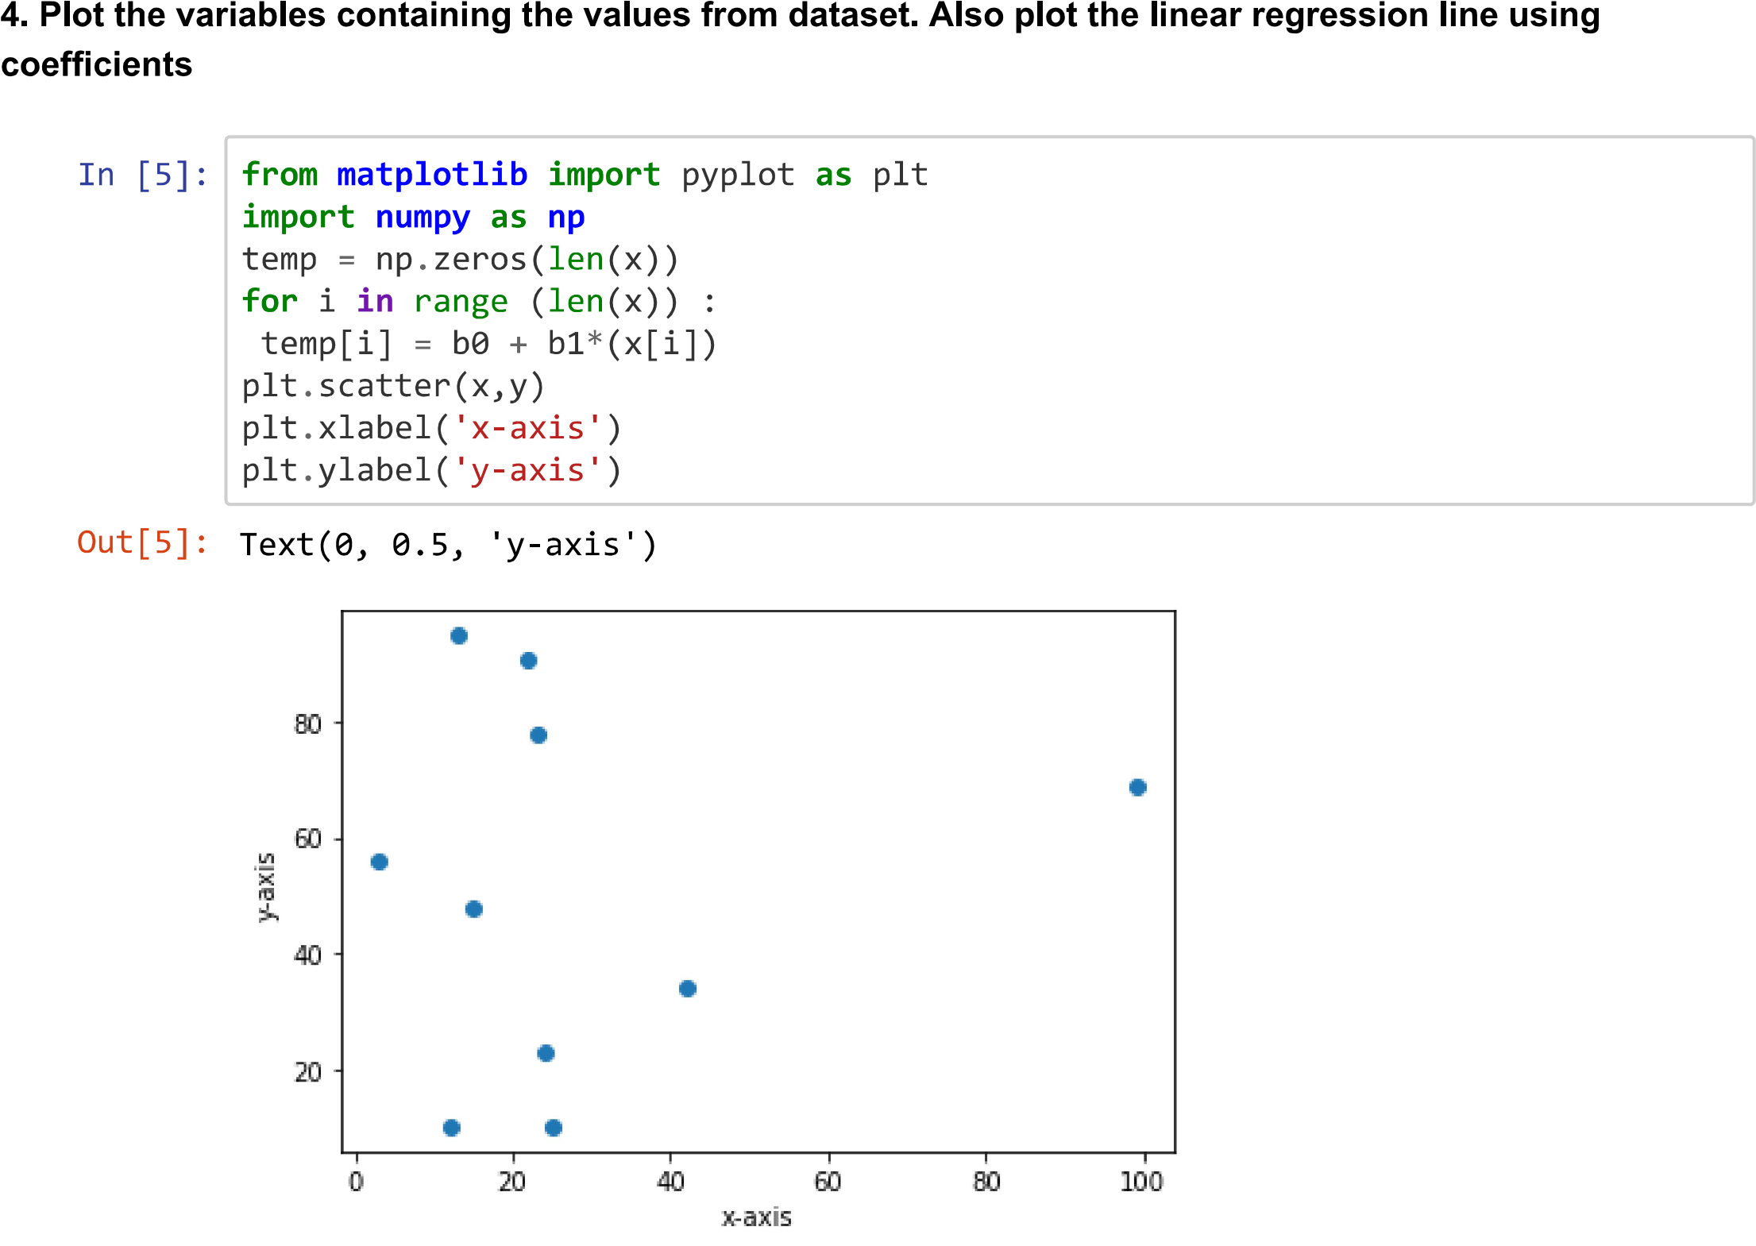

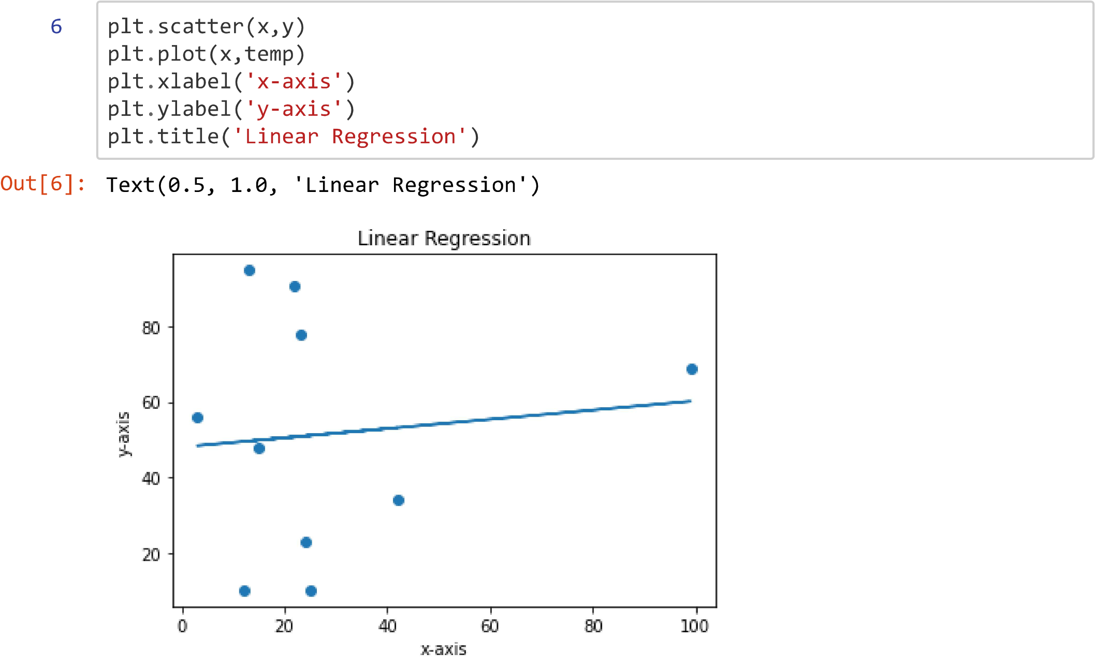

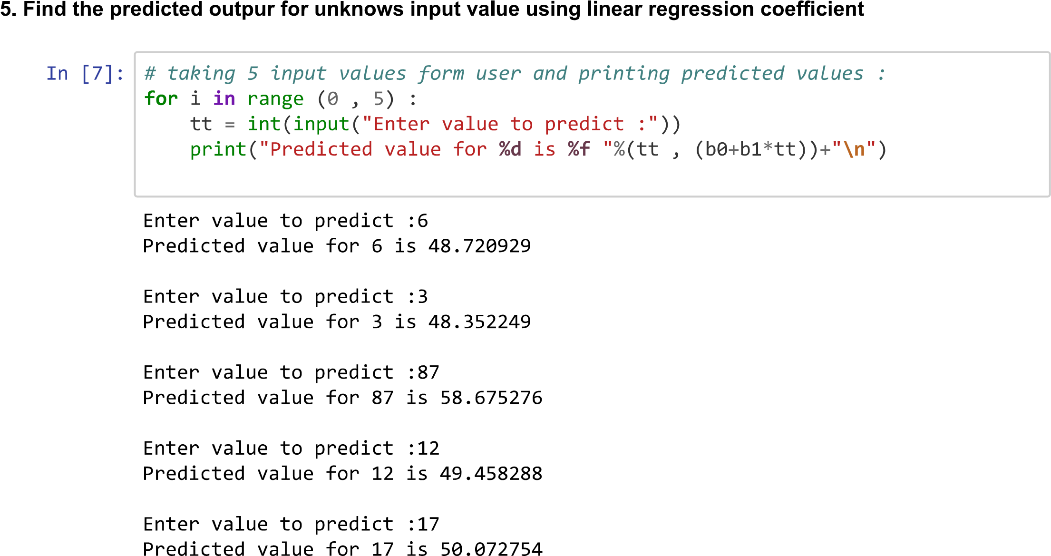

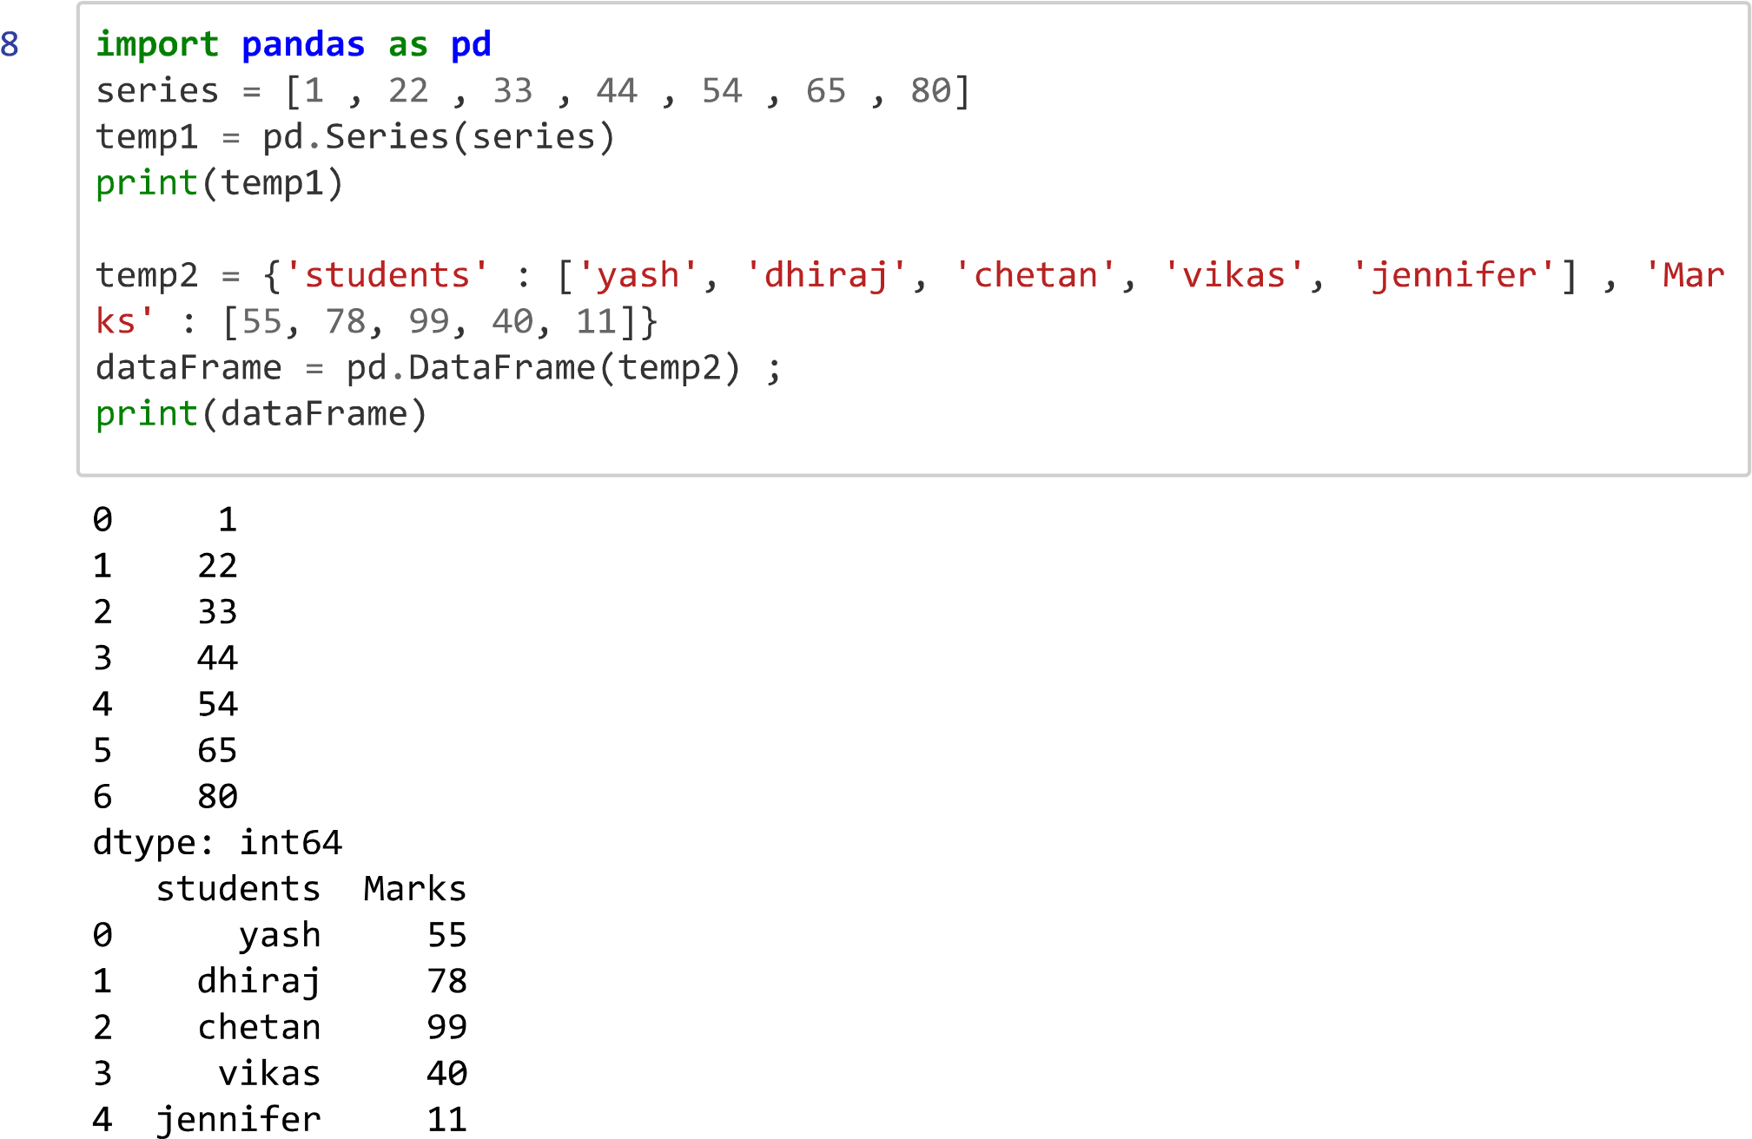

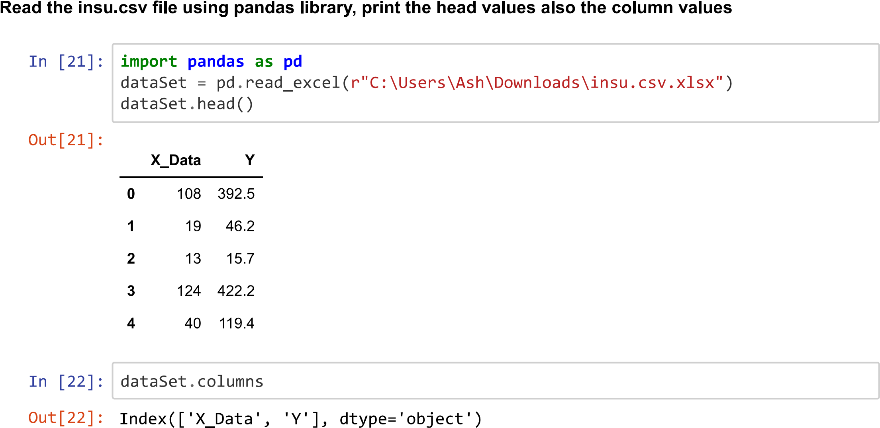

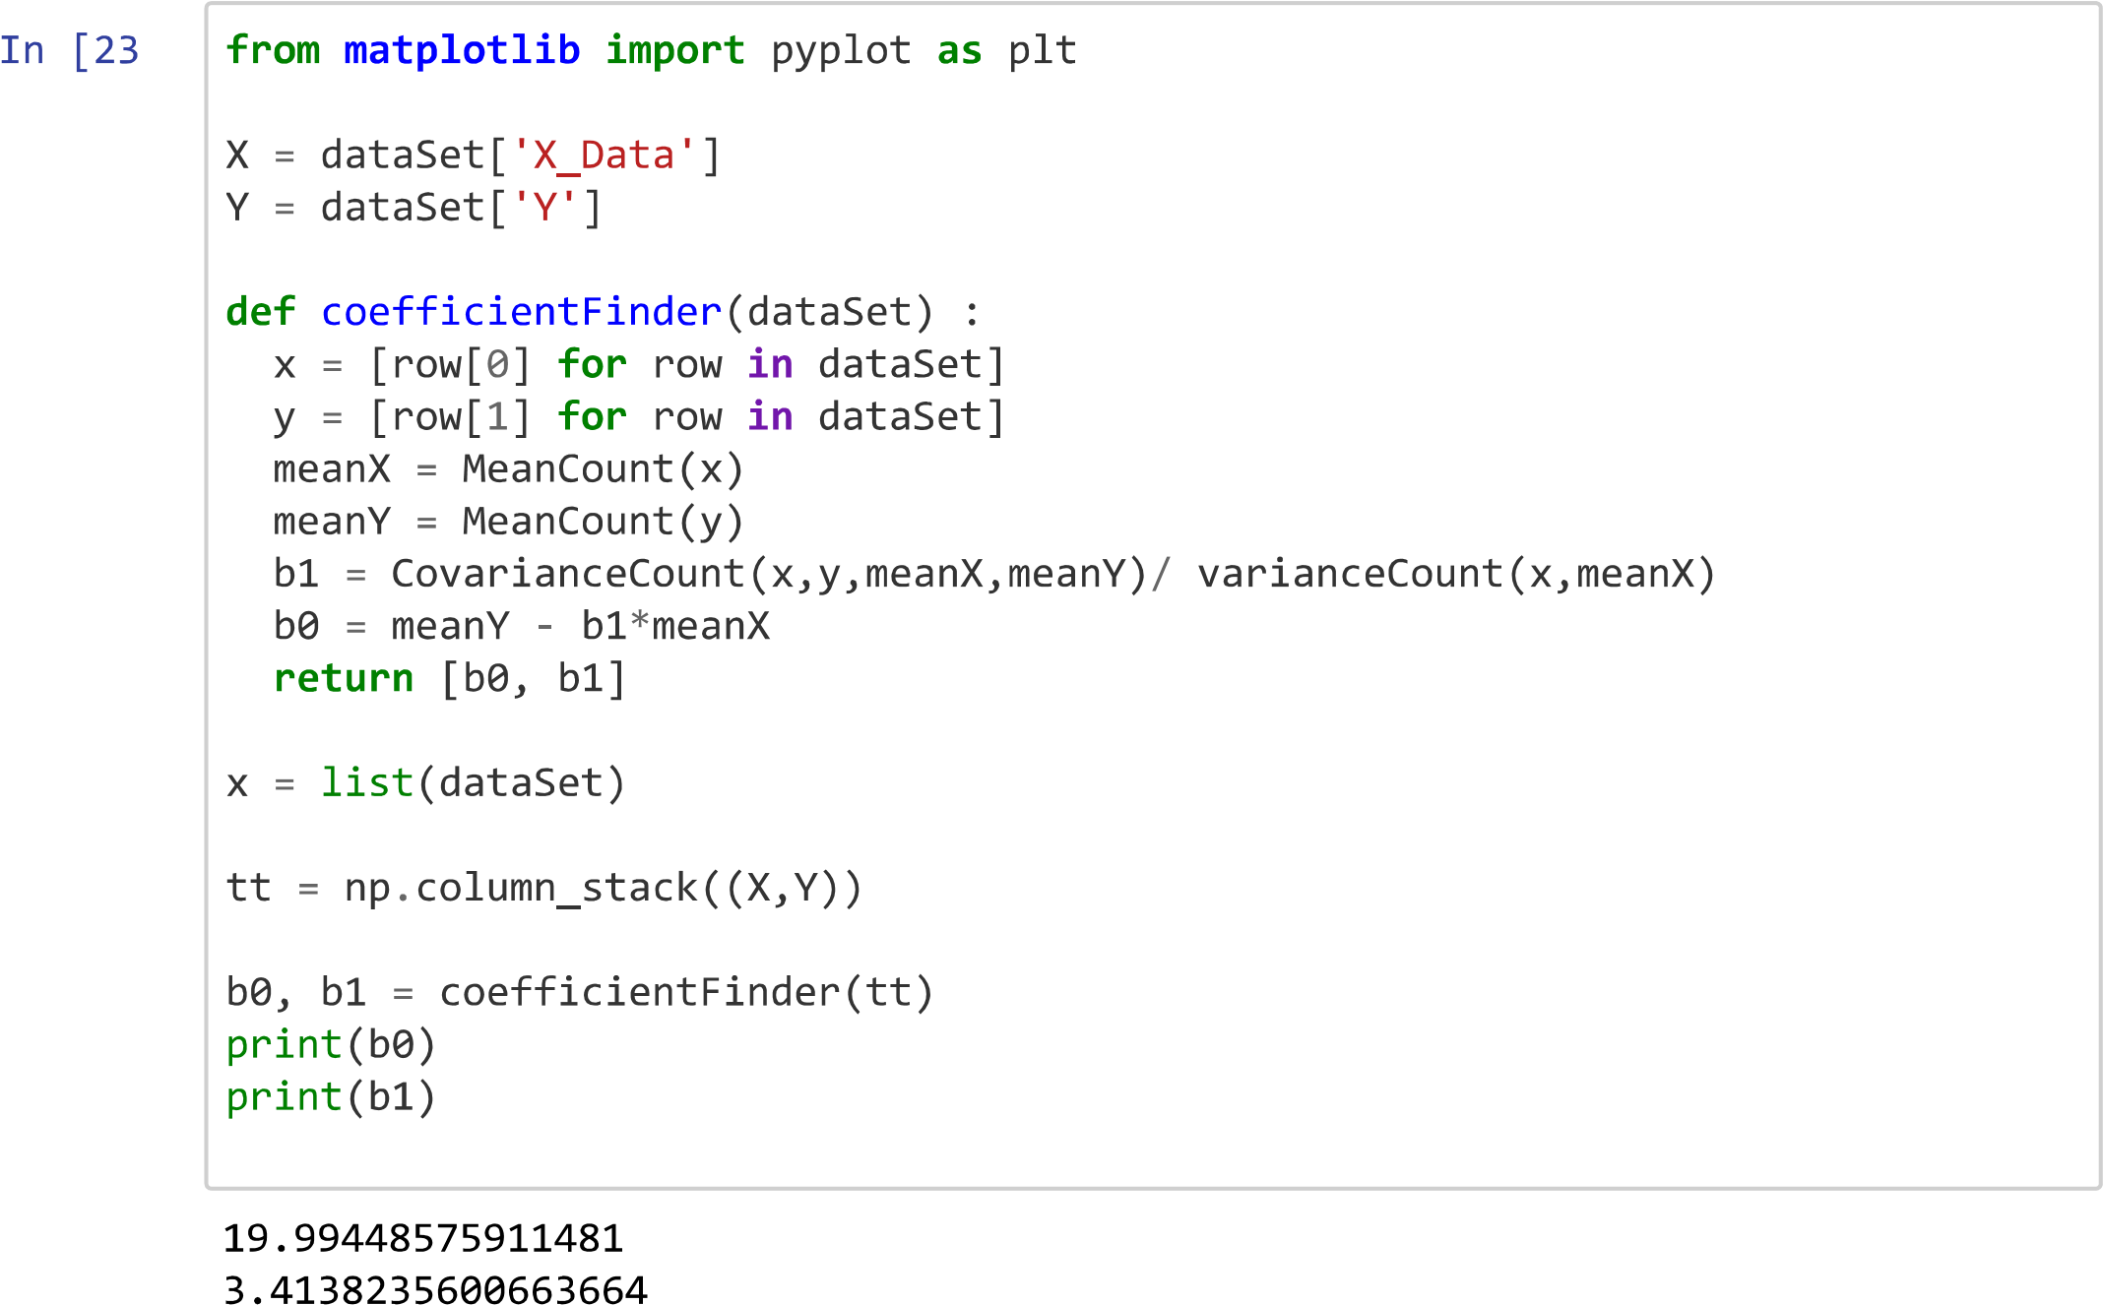

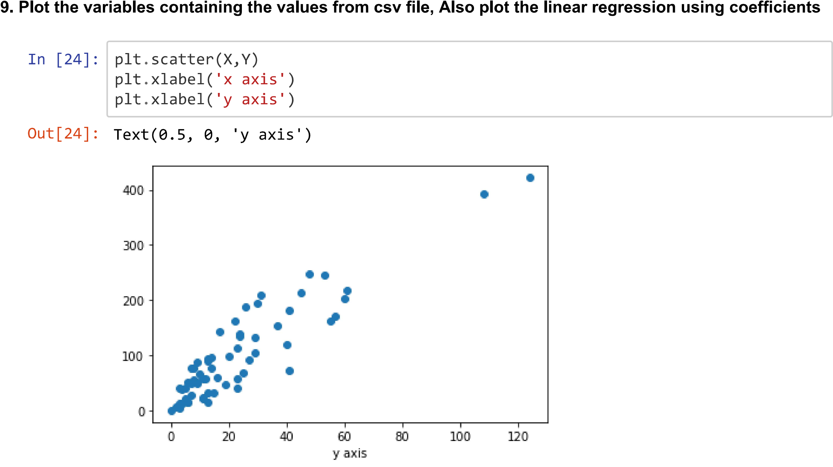

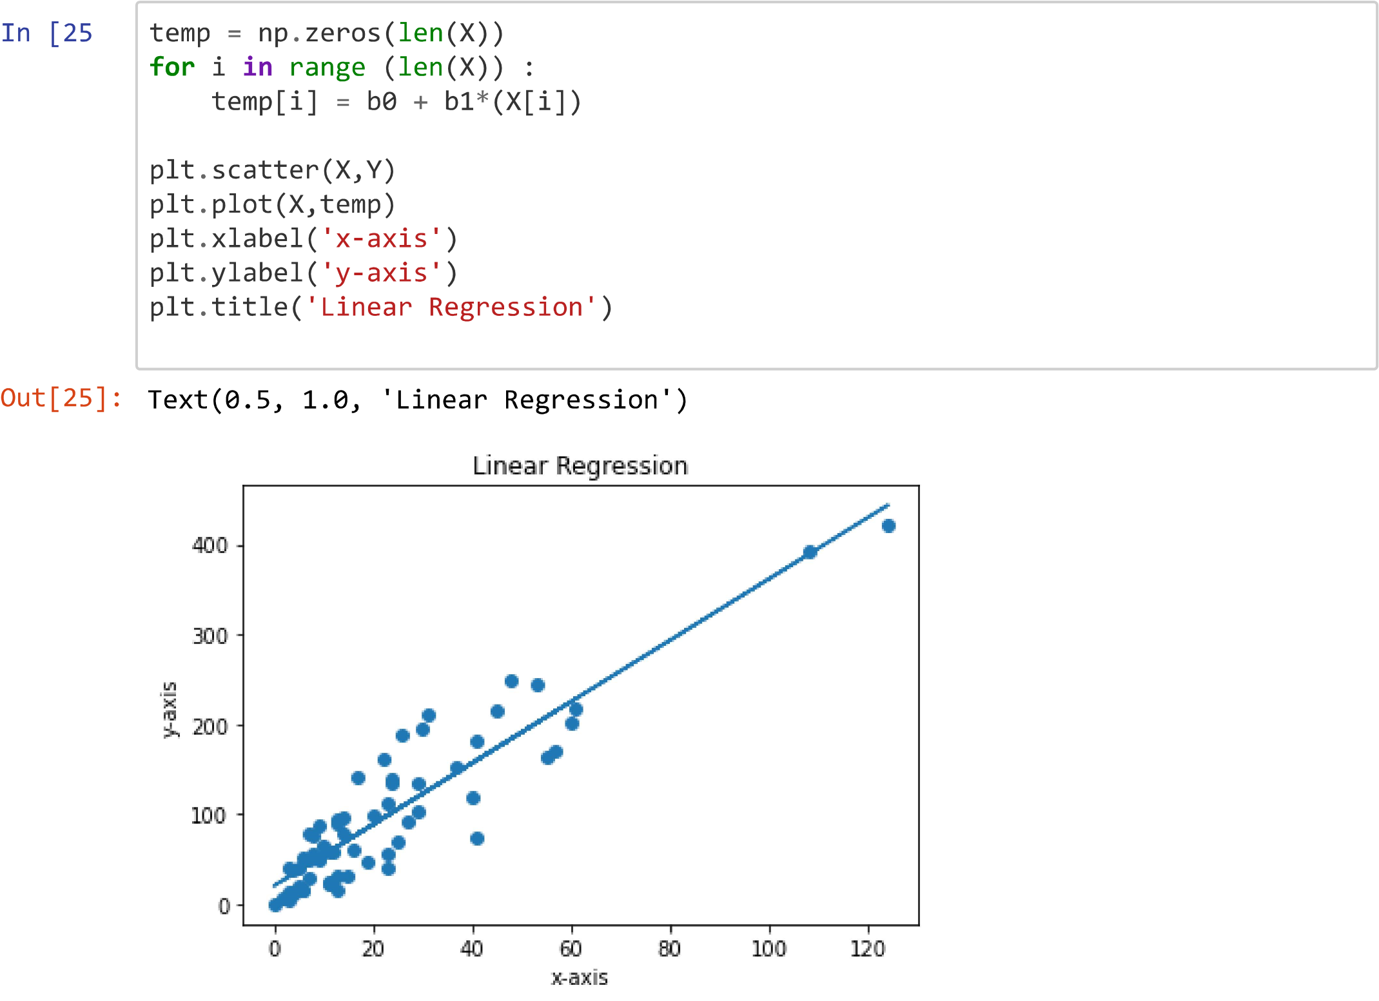

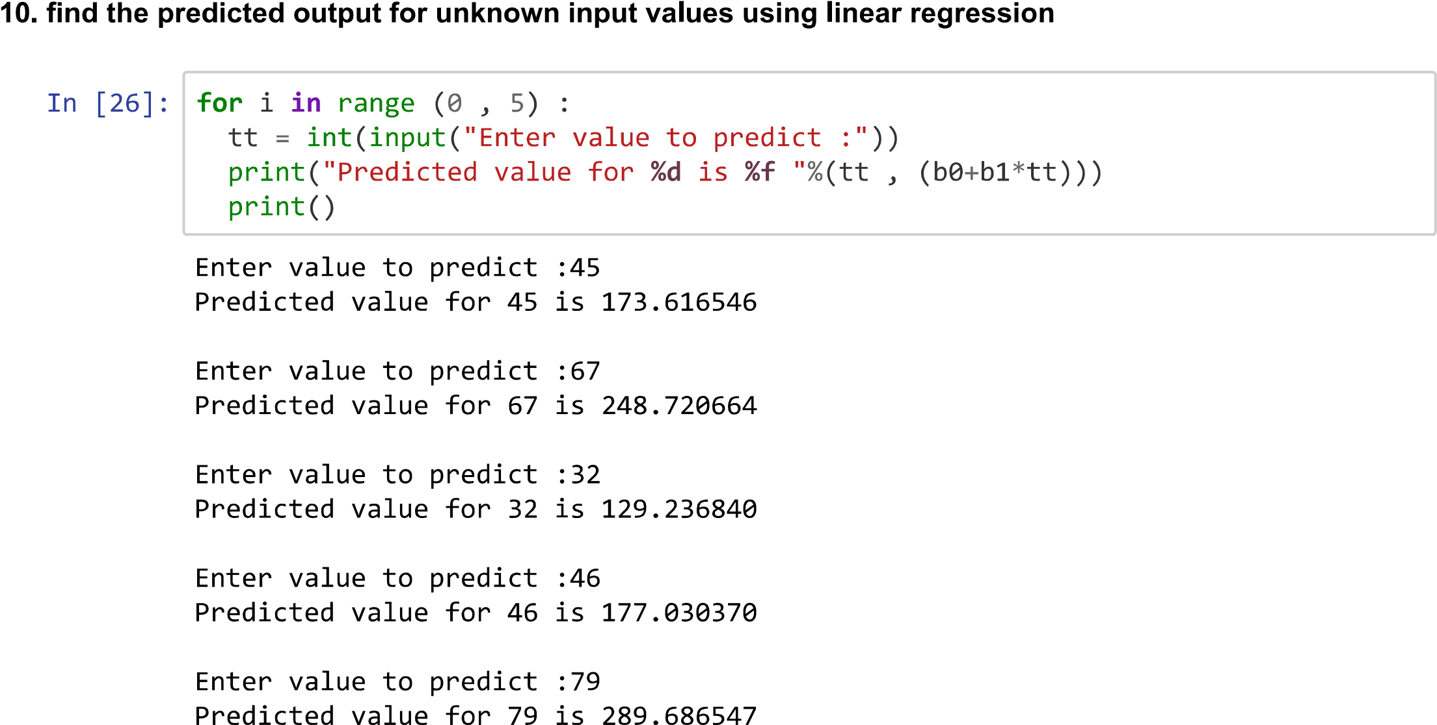

Name : Kiran Prakashrao Kadam

Reg. No. : 2019BEC147

Roll no. : A71

Batch : A3

Practical 4: Write a python program for implementation of Baye's Theorem

1. Define a function for computing the mean and variance of 1D data. Print mean and variance for two random vectors of length 10 and 5. Code for above operation is as follows :-

import numpy as np w1=np.array([1,3,4,12,7,6,8,89,43,71]) w2=np.array([10,13,54,12,17])

def stat(w):

mean = sum(w)/len(w) var = sum((w-mean)**2)/(len(w)) return mean, var

m1, v1 = stat(w1) m2,

v2 = stat(w2)

print("mean= {}, variance= {} for w1".format(m1,v1)) print("mean= {}, variance= {} for w2".format(m2,v2))

mean= 24.4, variance= 917.64 for w1 mean= 21.2,

variance= 274.15999999999997 for w2

2. If w1 = [1,3,8,12] with p(w1) =0.5 and w2-[6,9,13,16] with p(w2)=0.5, find the class for test samples 7.8, 9.6 and 11.5 using baye's rule. Code for above operation is as follows :-

w1=np.array([1,3,8,12]) w2=np.array([6,9,13,16]) p_w1 = 0.5 p_w2 = 0.5

m1, v1 = stat(w1) m2,

v2 = stat(w2)

print("mean= {}, variance= {} for w1".format(m1,v1)) print("mean= {}, variance= {} for w2".format(m2,v2)) mean= 6.0, variance= 18.5 for w1 mean= 11.0, variance= 14.5 for w2 x1=7.8 p_x1_w1 = np.exp(-0.5*((x1-m1)/v1)**2)/(np.sqrt(2*np.pi*v1**2)) p_x1_w2 = np.exp(-0.5*((x1-m2)/v1)**2)/(np.sqrt(2*np.pi*v1**2)) p_x1 = p_x1_w1*p_w1+p_x1_w2*p_w2

print("probability of x1 given w1= ", p_x1_w1) print("probability of x1 given w2= ", p_x1_w2) print("probability of x1 (evidence)= ",p_x1) print("\n") p_w1_x1 = p_x1_w1*p_w1/p_x1 p_w2_x1 = p_x1_w2*p_w2/p_x1

print("probability of w1 given x1 (posterior)= ", p_w1_x1)

print("probability of w2 given x1 (posterior)= ", p_w2_x1) print("\n")

if p_w1_x1 > p_w2_x1: print("data sample {} belongs to class w1".format(x1)) else:

print("data sample {} belongs to class w2".format(x1))

probability of x1 given w1= 0.0214626160145462 probability

of x1 given w2= 0.021244248268255928 probability of x1

(evidence)= 0.021353432141401063

probability of w1 given x1 (posterior)= 0.5025565883840624 probability

of w2 given x1 (posterior)= 0.49744341161593775

data sample 7.8 belongs to class w1

x1=9.6

p_x1_w1 = np.exp(-0.5*((x1-m1)/v1)**2)/(np.sqrt(2*np.pi*v1**2))

p_x1_w2 = np.exp(-0.5*((x1-m2)/v1)**2)/(np.sqrt(2*np.pi*v1**2)) p_x1 = p_x1_w1*p_w1+p_x1_w2*p_w2

print("probability of x1 given w1= ", p_x1_w1) print("probability of x1 given w2= ", p_x1_w2) print("probability of x1 (evidence)= ",p_x1) print("\n") p_w1_x1 = p_x1_w1*p_w1/p_x1 p_w2_x1 = p_x1_w2*p_w2/p_x1

print("probability of w1 given x1 (posterior)= ", p_w1_x1) print("probability of w2 given x1 (posterior)= ", p_w2_x1) print("\n")

if p_w1_x1 > p_w2_x1:

print("data sample {} belongs to class w1".format(x1)) else: print("data sample {} belongs to class w2".format(x1))

probability of x1 given w1= 0.021159997430760767

probability of x1 given w2= 0.021502788184998782 probability of x1 (evidence)= 0.021331392807879775

probability of w1 given x1 (posterior)= 0.495982555413454

probability of w2 given x1 (posterior)= 0.5040174445865461

data sample 9.6 belongs to class w2

Double-click (or enter) to edit

Double-click (or enter) to edit

Double-click (or enter) to edit

4. If w1= [5,6,9,10,14,18,8,4,7,9] with p(w1)=0.55 and w2 [11,15,17,14,13,8,12,9,10,21] with p(w2)=0.45, find the class for test samples 9.5,11.6,14.5,16.3,13.8 and 12.6 using baye's rule by defining function.

Code for above operation is as follows :-

w1=np.array([5,6,9,10,14,18,8,4,7,9])

w2=np.array([11,15,17,14,13,8,12,9,10,21])

0 p_w1 = 0.55

p_w2 = 0.45

m1, v1 = stat(w1)

m2, v2 = stat(w2)

print("mean= {}, variance= {} for w1".format(m1,v1))

print("mean= {}, variance= {} for w2".format(m2,v2))

mean= 9.0, variance= 16.2 for w1 mean=

13.0, variance= 14.0 for w2

x1=9.5 p_x1_w1 = np.exp(-0.5*((x1-m1)/v1)**2)/(np.sqrt(2*np.pi*v1**2)) p_x1_w2 = np.exp(-0.5*((x1-m2)/v1)**2)/(np.sqrt(2*np.pi*v1**2)) p_x1 = p_x1_w1*p_w1+p_x1_w2*p_w2

print("probability of x1 given w1= ", p_x1_w1) print("probability of x1 given w2= ", p_x1_w2) print("probability of x1 (evidence)= ",p_x1) print("\n") p_w1_x1 = p_x1_w1*p_w1/p_x1 p_w2_x1 = p_x1_w2*p_w2/p_x1

print("probability of w1 given x1 (posterior)= ", p_w1_x1)

print("probability of w2 given x1 (posterior)= ", p_w2_x1) print("\n")

if p_w1_x1 > p_w2_x1:

print("data sample {} belongs to class w1".format(x1)) else: print("data sample {} belongs to class w2".format(x1))

probability of x1 given w1= 0.02461434010492538

probability of x1 given w2= 0.024057982054693453 probability of x1 (evidence)= 0.024363978982321014

probability of w1 given x1 (posterior)= 0.5556517294458478 probability

of w2 given x1 (posterior)= 0.44434827055415216

data sample 9.5 belongs to class w1

x1=11.6 p_x1_w1 = np.exp(-0.5*((x1-m1)/v1)**2)/(np.sqrt(2*np.pi*v1**2)) p_x1_w2 = np.exp(-0.5*((x1-m2)/v1)**2)/(np.sqrt(2*np.pi*v1**2)) p_x1 = p_x1_w1*p_w1+p_x1_w2*p_w2

print("probability of x1 given w1= ", p_x1_w1) print("probability of x1 given w2= ", p_x1_w2) print("probability of x1 (evidence)= ",p_x1) print("\n") p_w1_x1 = p_x1_w1*p_w1/p_x1 p_w2_x1 = p_x1_w2*p_w2/p_x1

print("probability of w1 given x1 (posterior)= ", p_w1_x1)

print("probability of w2 given x1 (posterior)= ", p_w2_x1) print("\n") if p_w1_x1 > p_w2_x1:

print("data sample {} belongs to class w1".format(x1)) else:

print("data sample {} belongs to class w2".format(x1))

probability of x1 given w1= 0.024310937920568758 probability of x1 given w2= 0.02453427983803896 probability of x1 (evidence)= 0.024411441783430347

probability of w1 given x1 (posterior)= 0.5477356059070877 probability of w2 given x1 (posterior)= 0.4522643940929124

data sample 11.6 belongs to class w1

x1=14.5 p_x1_w1 = np.exp(-0.5*((x1-m1)/v1)**2)/(np.sqrt(2*np.pi*v1**2)) p_x1_w2 = np.exp(-0.5*((x1-m2)/v1)**2)/(np.sqrt(2*np.pi*v1**2)) p_x1 = p_x1_w1*p_w1+p_x1_w2*p_w2

print("probability of x1 given w1= ", p_x1_w1) print("probability of x1 given w2= ", p_x1_w2) print("probability of x1 (evidence)= ",p_x1) print("\n") p_w1_x1 = p_x1_w1*p_w1/p_x1 p_w2_x1 = p_x1_w2*p_w2/p_x1 print("probability of w1 given x1 (posterior)= ", p_w1_x1) print("probability of w2 given x1 (posterior)= ", p_w2_x1) print("\n")

if p_w1_x1 > p_w2_x1:

print("data sample {} belongs to class w1".format(x1)) else:

print("data sample {} belongs to class w2".format(x1))

probability of x1 given w1= 0.02324693470836149 probability of x1 given w2= 0.024520728214836092 probability of x1 (evidence)= 0.023820141786275062

probability of w1 given x1 (posterior)= 0.5367648187957422 probability of w2 given x1 (posterior)= 0.4632351812042578

data sample 14.5 belongs to class w1

x1=16.3

p_x1_w1 = np.exp(-0.5*((x1-m1)/v1)**2)/(np.sqrt(2*np.pi*v1**2)) p_x1_w2 = np.exp(-0.5*((x1-m2)/v1)**2)/(np.sqrt(2*np.pi*v1**2)) p_x1 = p_x1_w1*p_w1+p_x1_w2*p_w2

print("probability of x1 given w1= ", p_x1_w1) print("probability of x1 given w2= ", p_x1_w2) print("probability of x1 (evidence)= ",p_x1) print("\n") p_w1_x1 = p_x1_w1*p_w1/p_x1 p_w2_x1 = p_x1_w2*p_w2/p_x1

print("probability of w1 given x1 (posterior)= ", p_w1_x1) print("probability of w2 given x1 (posterior)= ", p_w2_x1) print("\n")

if p_w1_x1 > p_w2_x1:

print("data sample {} belongs to class w1".format(x1)) else:

print("data sample {} belongs to class w2".format(x1))

probability of x1 given w1= 0.022248565513746862 probability of x1 given w2= 0.024120398760655765 probability of x1 (evidence)= 0.023090890474855873

probability of w1 given x1 (posterior)= 0.5299367317984368 probability of w2 given x1 (posterior)= 0.4700632682015631

data sample 16.3 belongs to class w1

Double-click (or enter) to edit

x1=13.8 p_x1_w1 = np.exp(-0.5*((x1-m1)/v1)**2)/(np.sqrt(2*np.pi*v1**2)) p_x1_w2 = np.exp(-0.5*((x1-m2)/v1)**2)/(np.sqrt(2*np.pi*v1**2)) p_x1 = p_x1_w1*p_w1+p_x1_w2*p_w2

print("probability of x1 given w1= ", p_x1_w1) print("probability of x1 given w2= ", p_x1_w2) print("probability of x1 (evidence)= ",p_x1) print("\n") p_w1_x1 = p_x1_w1*p_w1/p_x1 p_w2_x1 = p_x1_w2*p_w2/p_x1

print("probability of w1 given x1 (posterior)= ", p_w1_x1) print("probability of w2 given x1 (posterior)= ", p_w2_x1) print("\n")

if p_w1_x1 > p_w2_x1: print("data sample {} belongs to class w1".format(x1)) else:

print("data sample {} belongs to class w2".format(x1))

probability of x1 given w1= 0.02356846891876366

probability of x1 given w2= 0.024596057779163474 probability of x1 (evidence)= 0.02403088390594358

probability of w1 given x1 (posterior)= 0.5394166088961025 probability

of w2 given x1 (posterior)= 0.46058339110389734

data sample 13.8 belongs to class w1

x1=12.6 p_x1_w1 = np.exp(-0.5*((x1-m1)/v1)**2)/(np.sqrt(2*np.pi*v1**2)) p_x1_w2 = np.exp(-0.5*((x1-m2)/v1)**2)/(np.sqrt(2*np.pi*v1**2)) p_x1 = p_x1_w1*p_w1+p_x1_w2*p_w2

print("probability of x1 given w1= ", p_x1_w1) print("probability of x1 given w2= ", p_x1_w2) print("probability of x1 (evidence)= ",p_x1) print("\n") p_w1_x1 = p_x1_w1*p_w1/p_x1 p_w2_x1 = p_x1_w2*p_w2/p_x1

print("probability of w1 given x1 (posterior)= ", p_w1_x1)

print("probability of w2 given x1 (posterior)= ", p_w2_x1) print("\n")

if p_w1_x1 > p_w2_x1: print("data sample {} belongs to class w1".format(x1)) else:

print("data sample {} belongs to class w2".format(x1))

probability of x1 given w1= 0.02402546105998434

probability of x1 given w2= 0.02461856103265317 probability of x1 (evidence)= 0.024292356047685315

probability of w1 given x1 (posterior)= 0.5439572661067792

probability of w2 given x1 (posterior)= 0.4560427338932208

data sample 12.6 belongs to class w1

5. Define the function for computing the mean and covariance matrix for 2D data. Print the individual mean & co-variance matrix for [[3,5], [8,7],[4,6]] and [[4,7],[8,6],[3,2]].

Code for above operation is as follows :-

Double-click (or enter) to edit

List item

List item

Double-click (or enter) to edit

def stat(w):

mean = sum(w)/len(w) var = sum((w-mean)**2)/(len(w)) return mean, var

m1, v1 = stat(w1) m2, v2 = stat(w2) def stat(s):

p_x1_w1 = np.exp(-0.5*((x1-m1)/v1)**2)/(np.sqrt(2*np.pi*v1**2)) p_x1_w2 = np.exp(-0.5*((x1-m2)/v1)**2)/(np.sqrt(2*np.pi*v1**2)) p_x1 = p_x1_w1*p_w1+p_x1_w2*p_w2

print("probability of x1 given w1= ", p_x1_w1) print("probability of x1 given w2= ", p_x1_w2) print("probability of x1 (evidence)= ",p_x1) print("\n") p_w1_x1 = p_x1_w1*p_w1/p_x1 p_w2_x1 = p_x1_w2*p_w2/p_x1

print("probability of w1 given x1 (posterior)= ", p_w1_x1)

print("probability of w2 given x1 (posterior)= ", p_w2_x1) print("\n")

if p_w1_x1 > p_w2_x1: print("data sample {} belongs to class w1".format(x1)) else: print("data sample {} belongs to class w2".format(x1)) return s,x1 m1, v1 = stat(w1) m2, v2 = stat(w2)

Name:-Kiran Prakashrao Kadam

Reg no:-2019BEC147

Roll no:-A71

Practical:-05

1

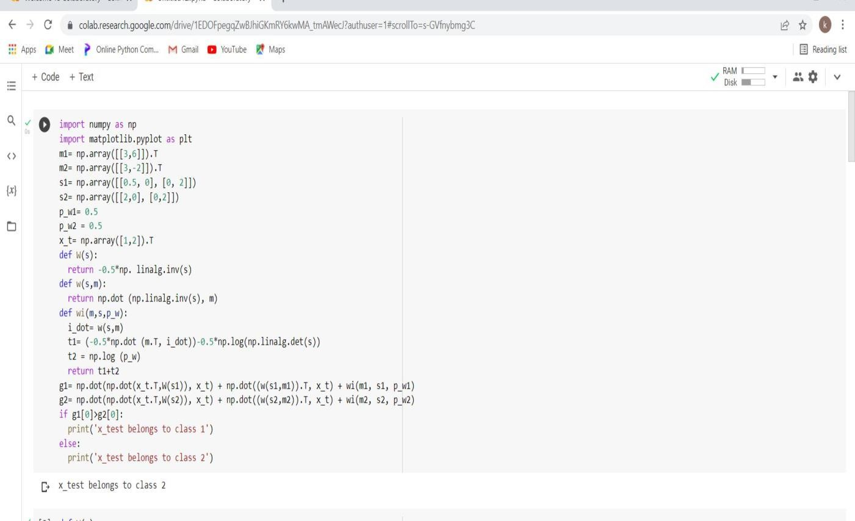

2

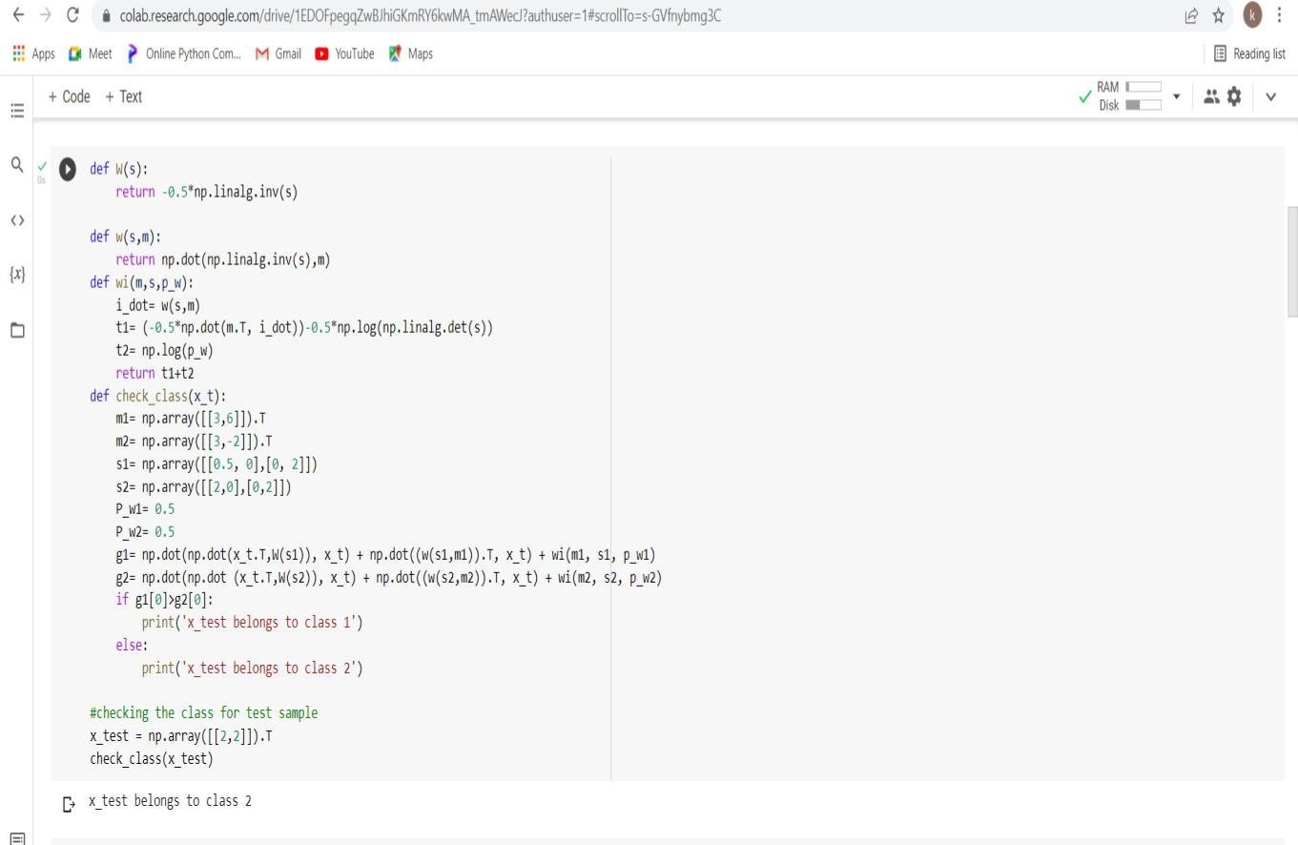

3

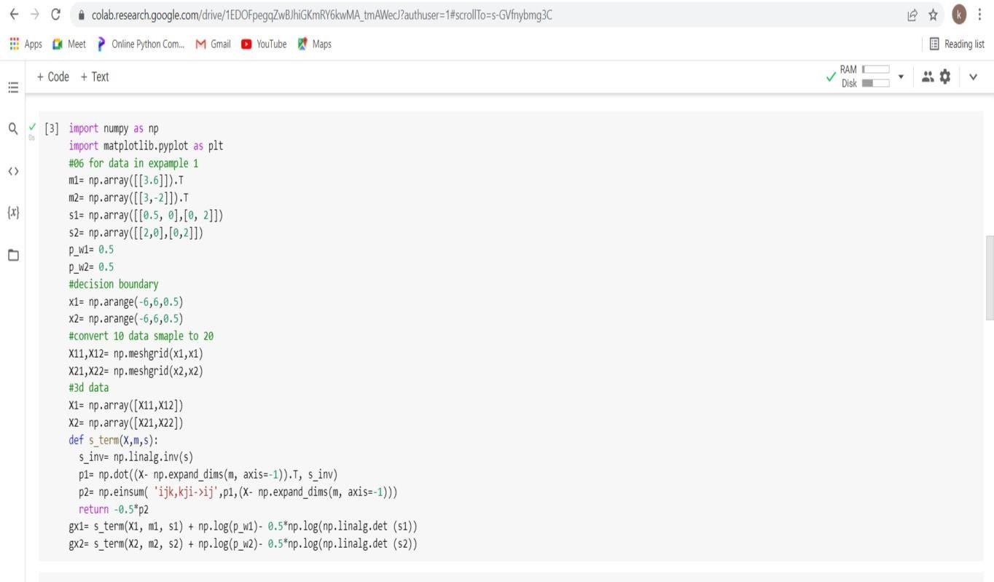

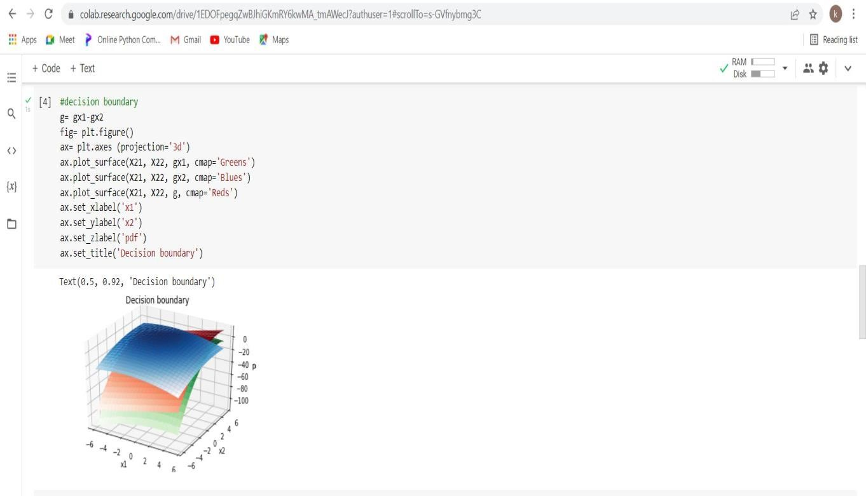

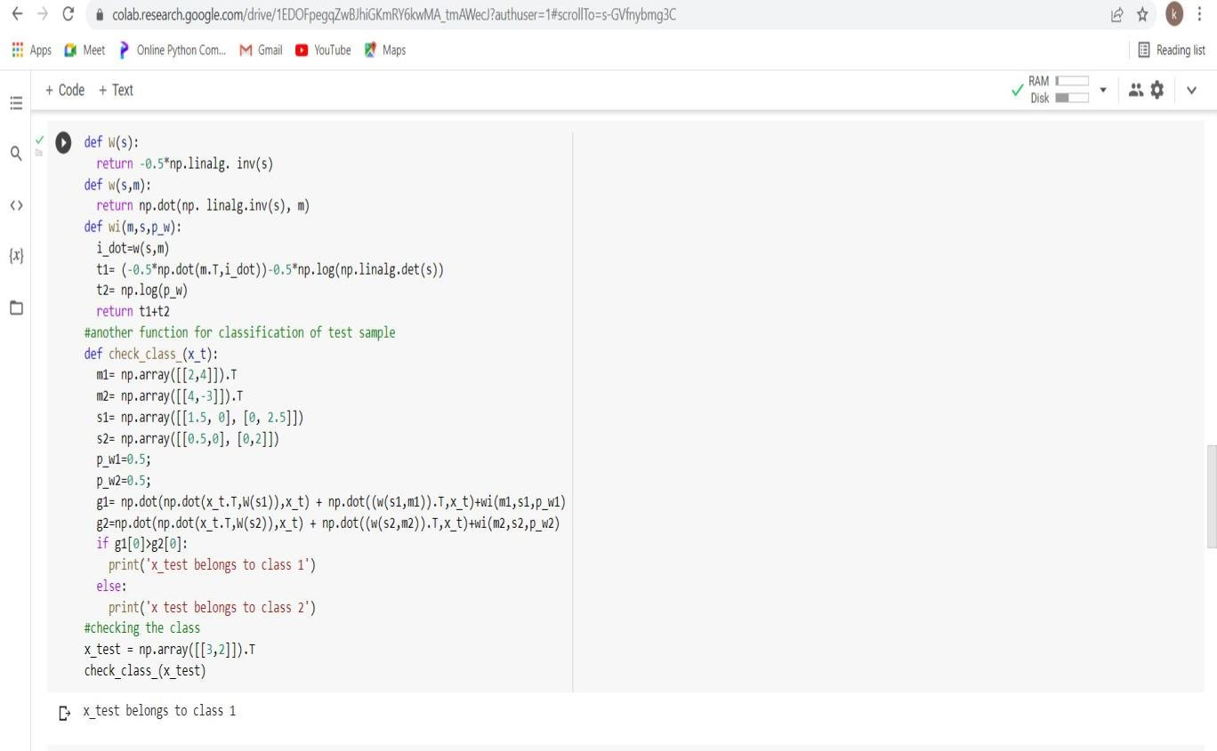

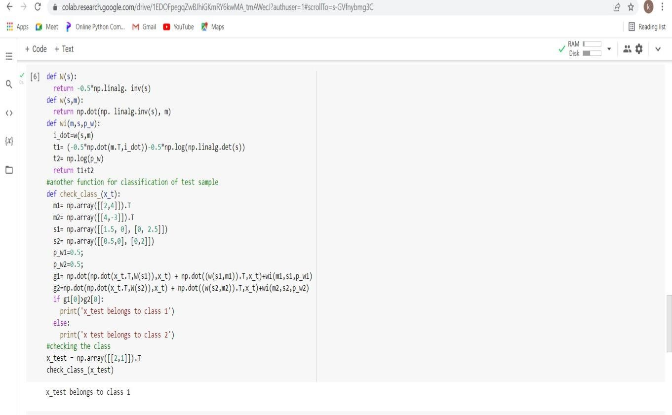

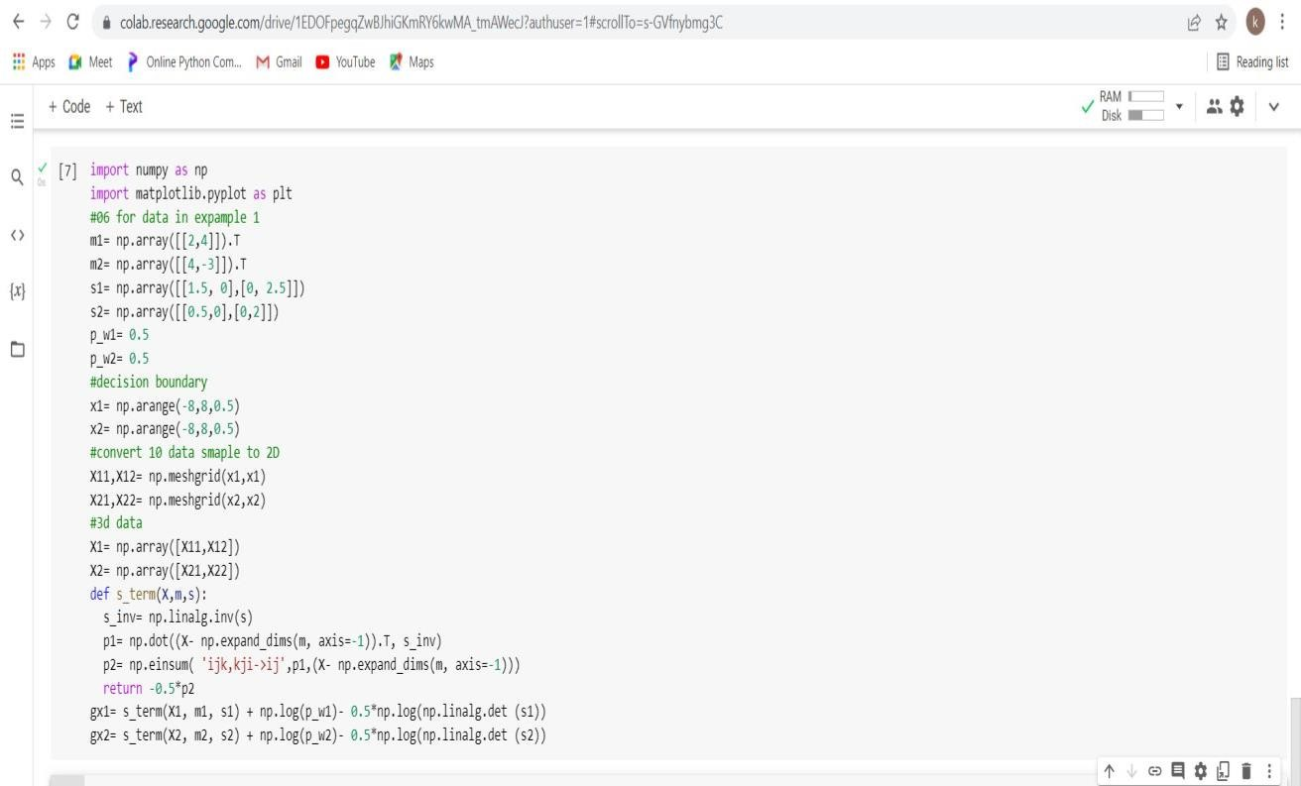

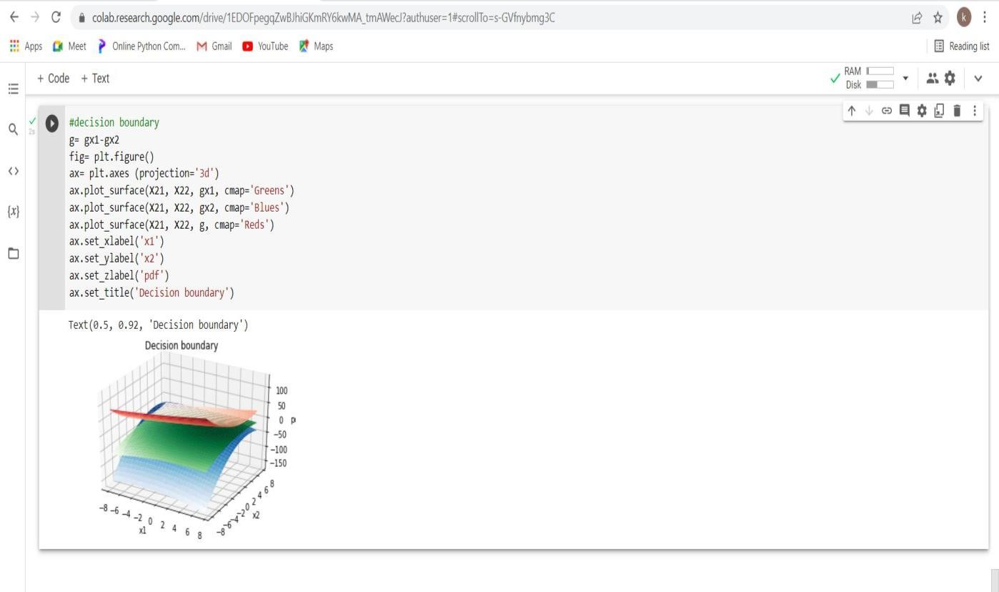

https://colab.research.google.com/drive/1EDOFpegqZwBJhiGKmRY6kwMA_tmAWecJ?usp=sharing

**Name : Kiran Prakashrao Kadam**

**Roll no: A71**

**Reg no : 2019BEC147 Batch : A3**

**Machine Learning**

# Practical No.6

**Aim:**

Write a python program to implement Naïve Bayes Classifier.

**Tool Used:**

Google colaboratory

**Programs:**

**1.If Cook is Sita, Mood is Bad and preparing Continental food, is food tasty?**

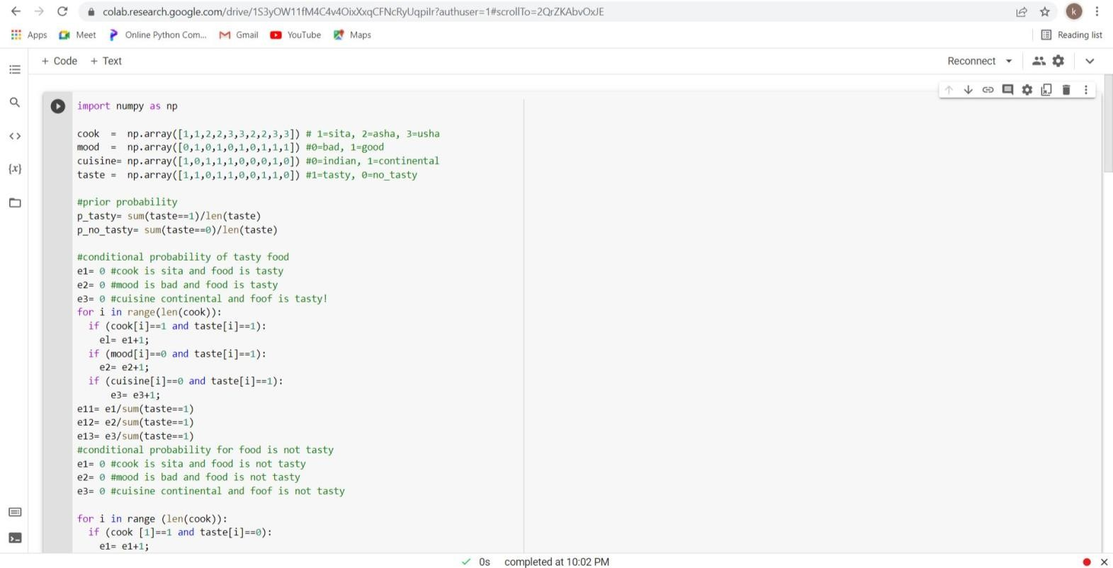

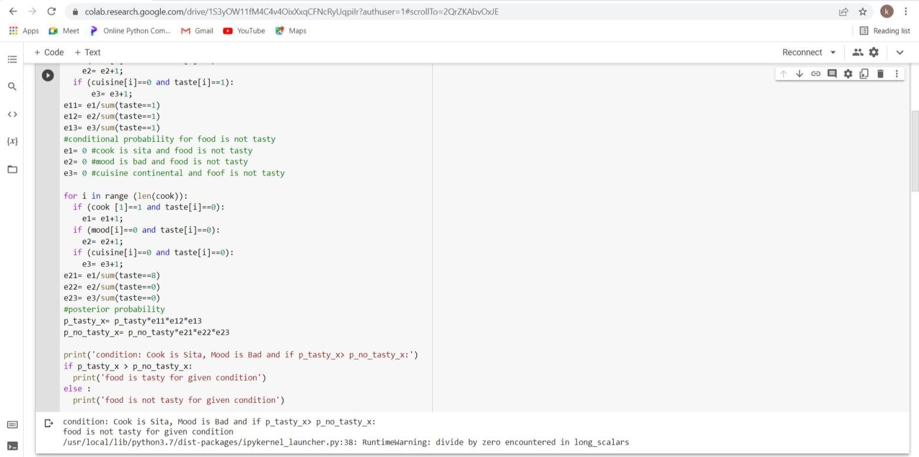

**2.If Cook is Asha for above case, is food tasty?**



**3.If Cook is Usha, Mood is Bad and preparing Continental food, is food tasty?**

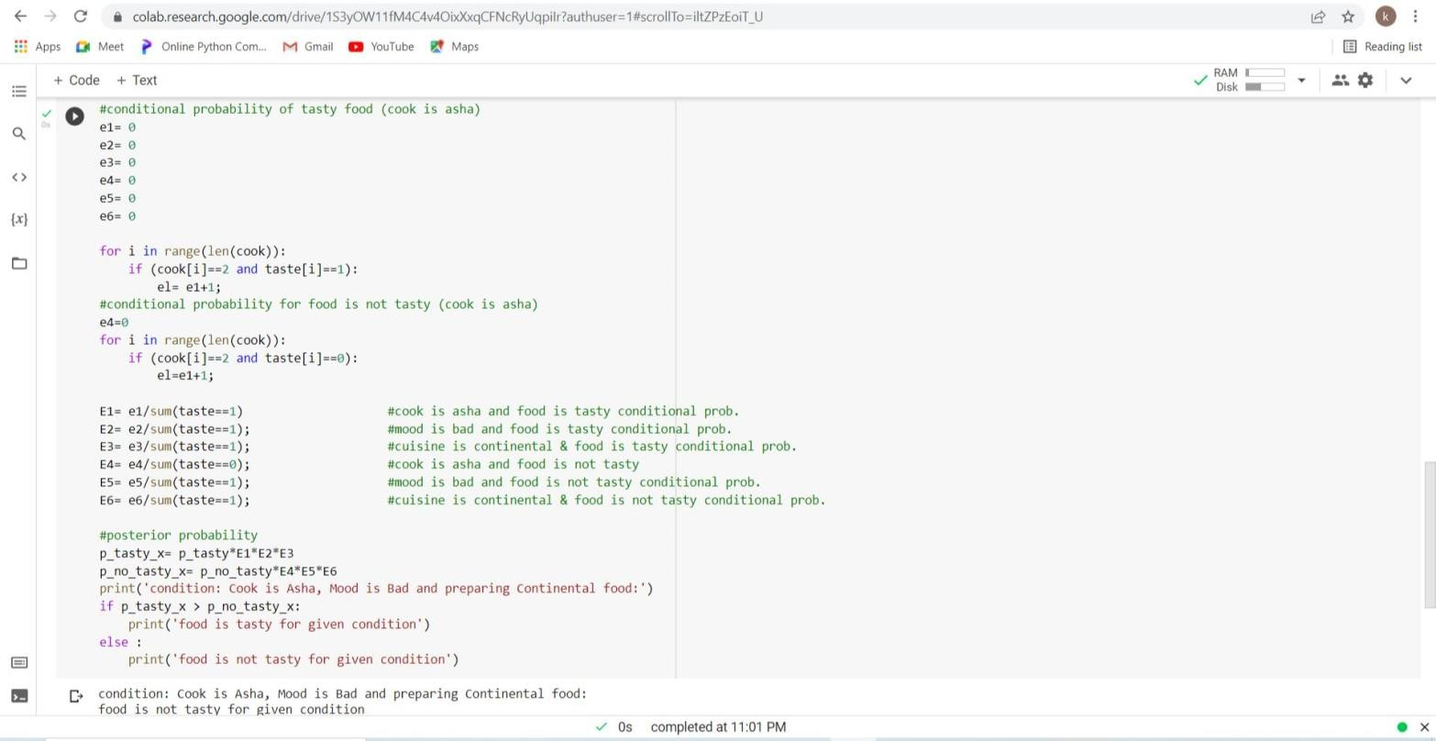

**4.If car Color is Red, Type is Sedan and Origin is Domestic, was car stolen?**



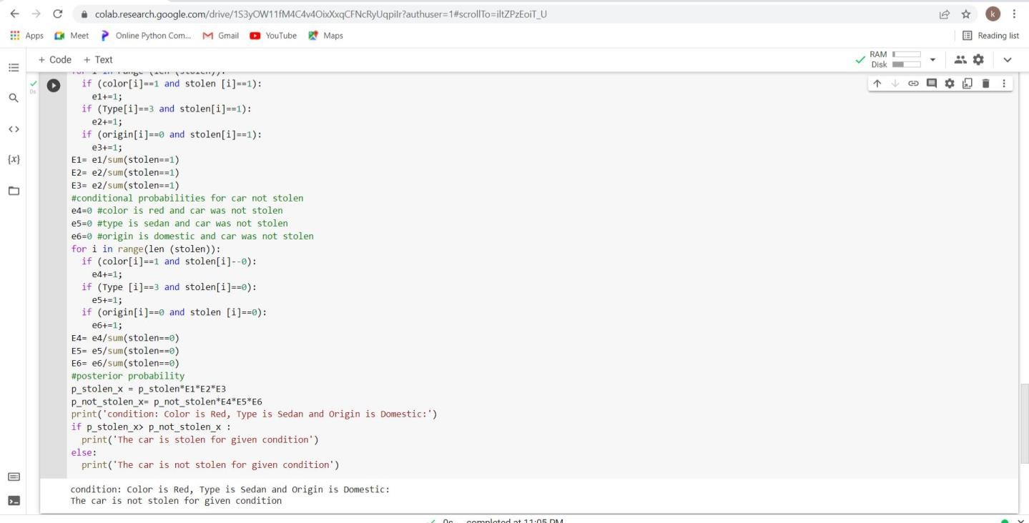

**5.If car Color is White, Type is SUV and Origin is Imported, was car stolen?**

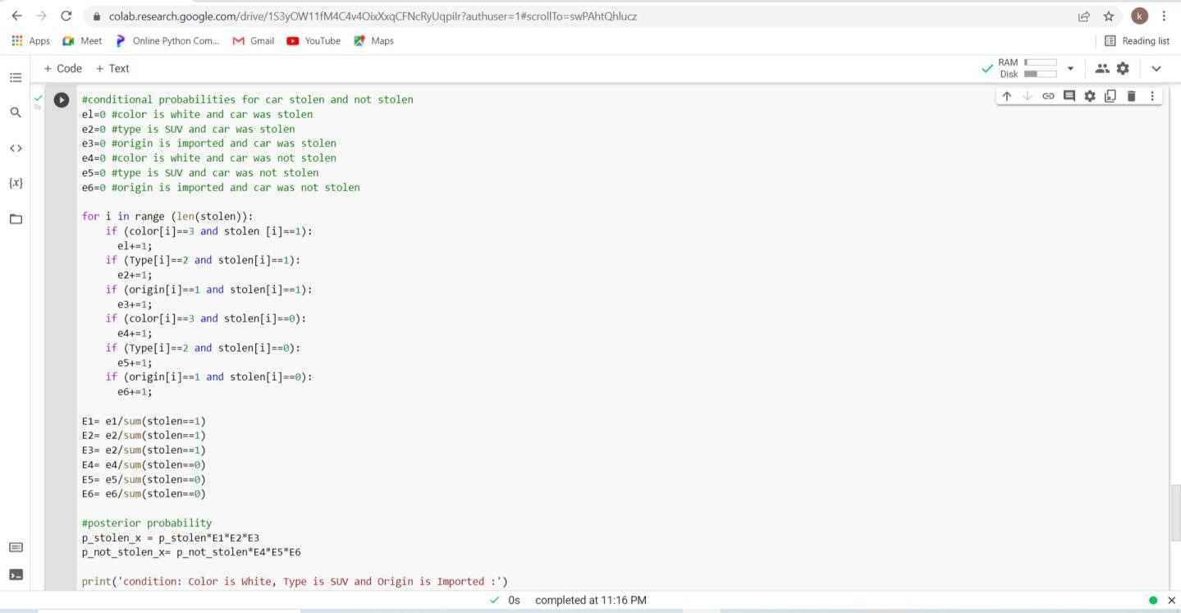

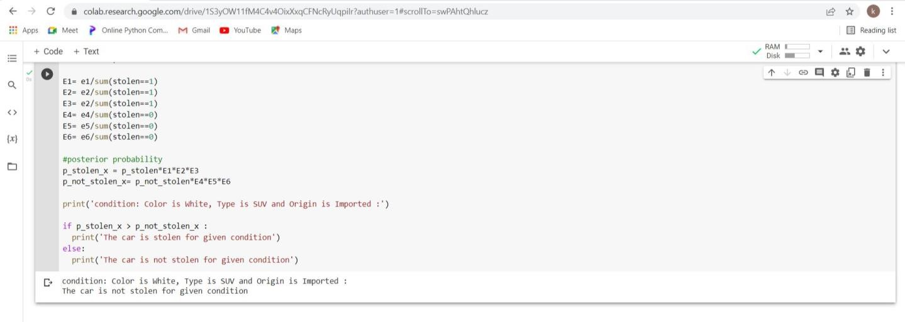

**6.If car Color is Blue, Type is Sports and Origin is Domestic, was car stolen?**





**7.If car Color is White, Type is Sedan and Origin is Domestic, was car stolen?**

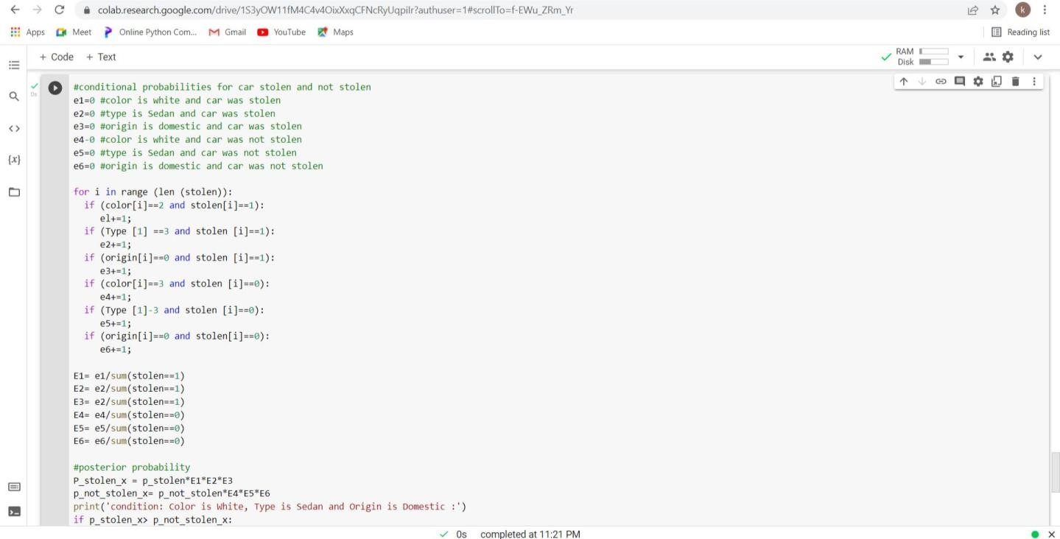



**8.If car Color is Bleu, Type is Sports and Origin is Imported, was car stolen?**

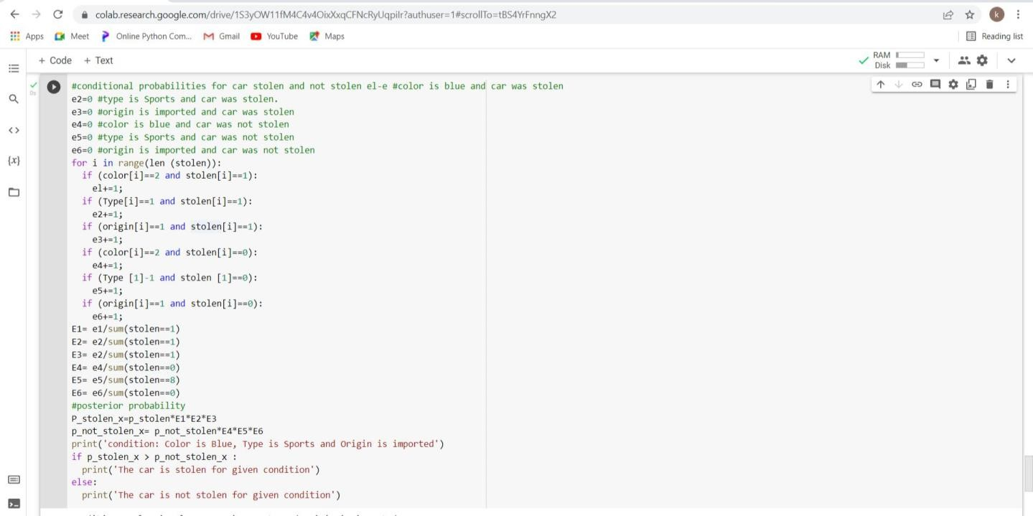



**9.If car Color is Red, Type is Sedan and Origin is Domestic, was car stolen?**

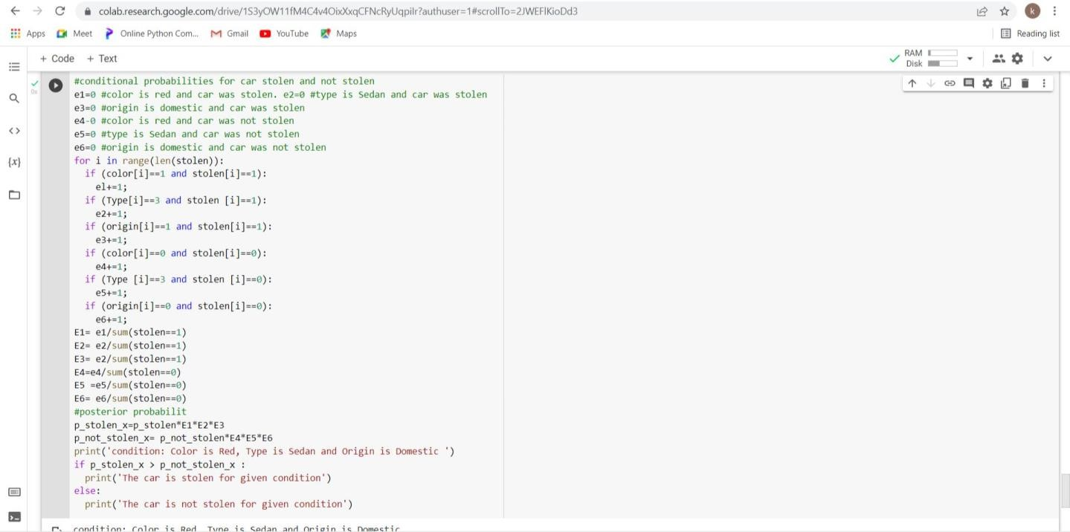



**Conclusion:**

Hence, Naïve Bayes classifiers are a collection of classification algorithms based on Bayes’ Theorem to predict outcome. It is family of algorithms where all of them share a common principle. Naïve Bayes algorithms are mostly used in sentiment analysis, spam filtering, recommendation systems etc. They are fast and easy to implement.

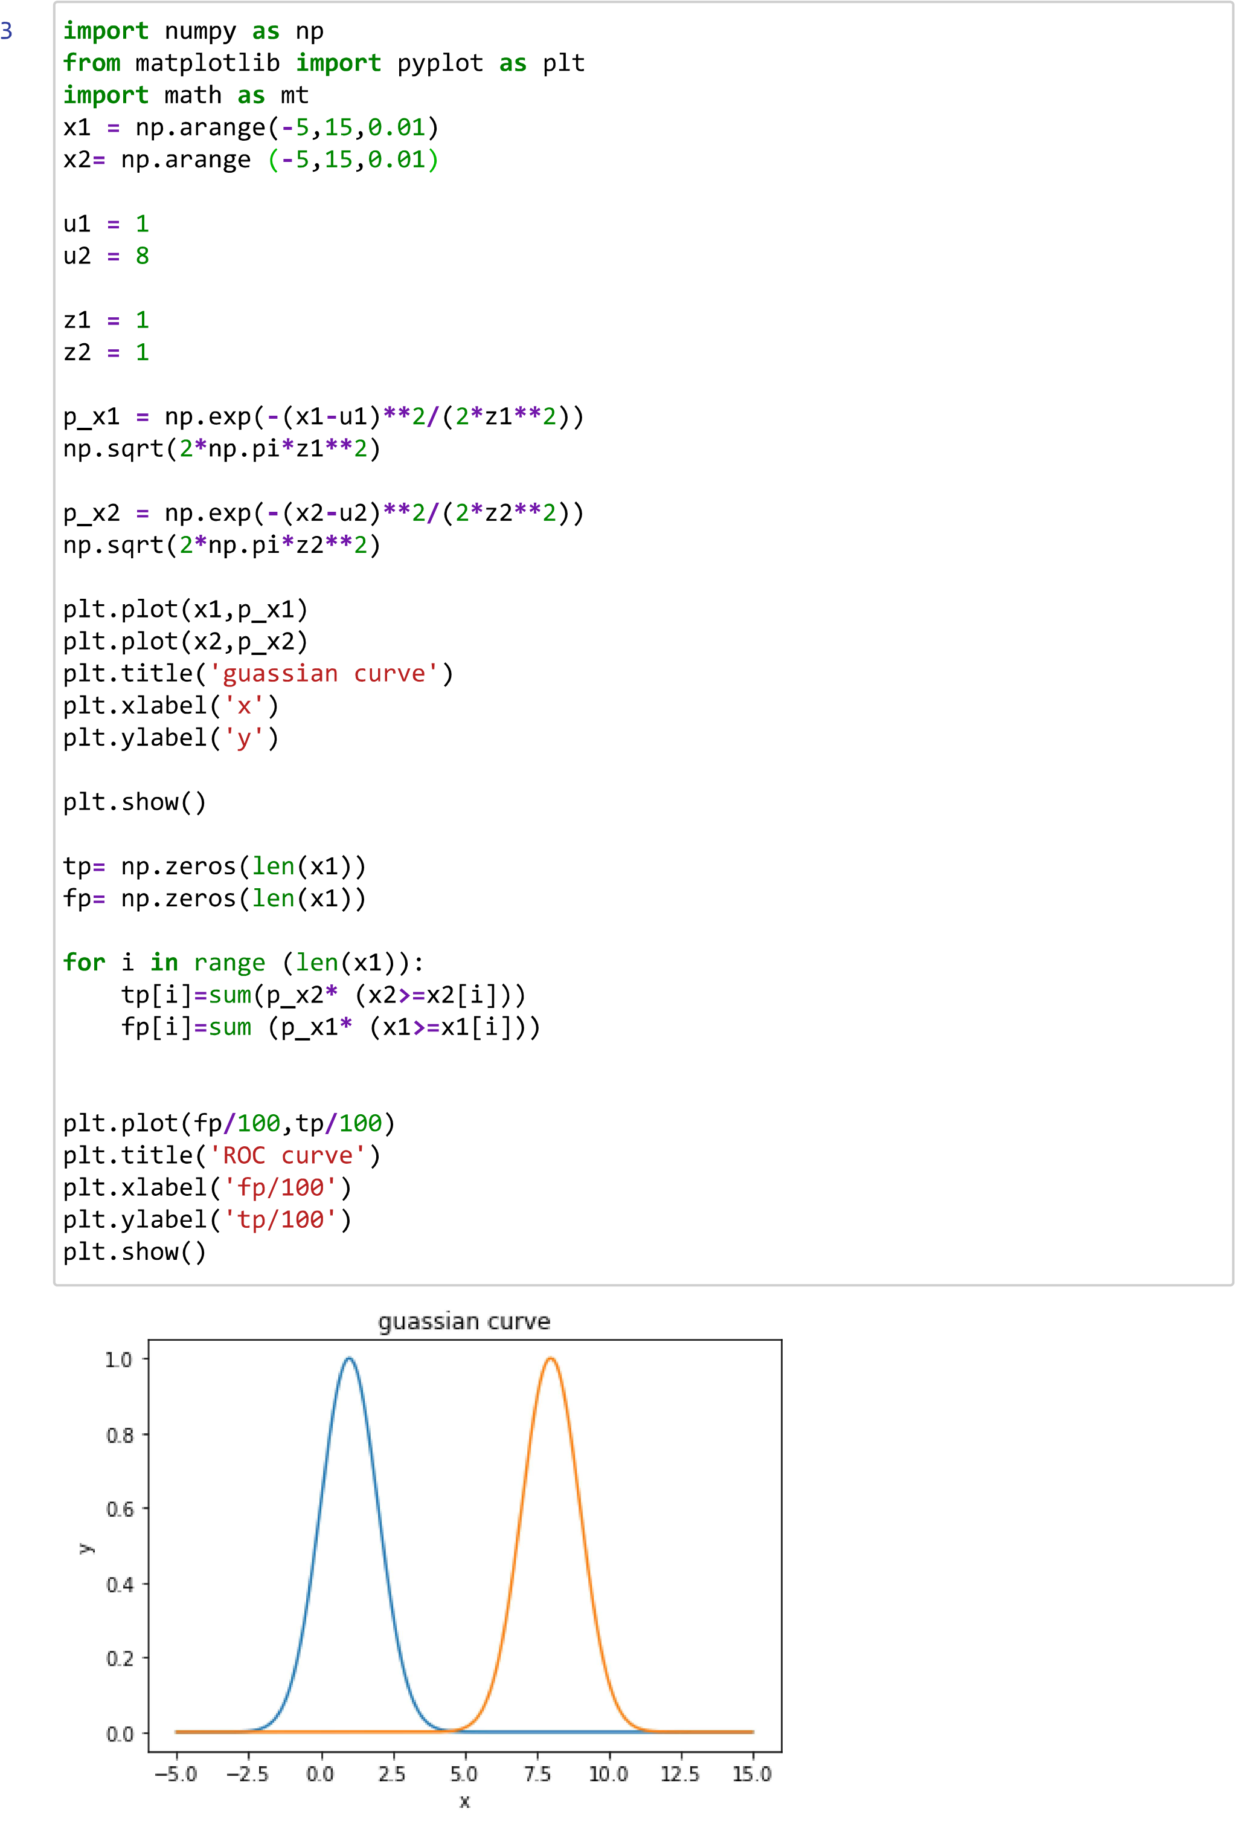

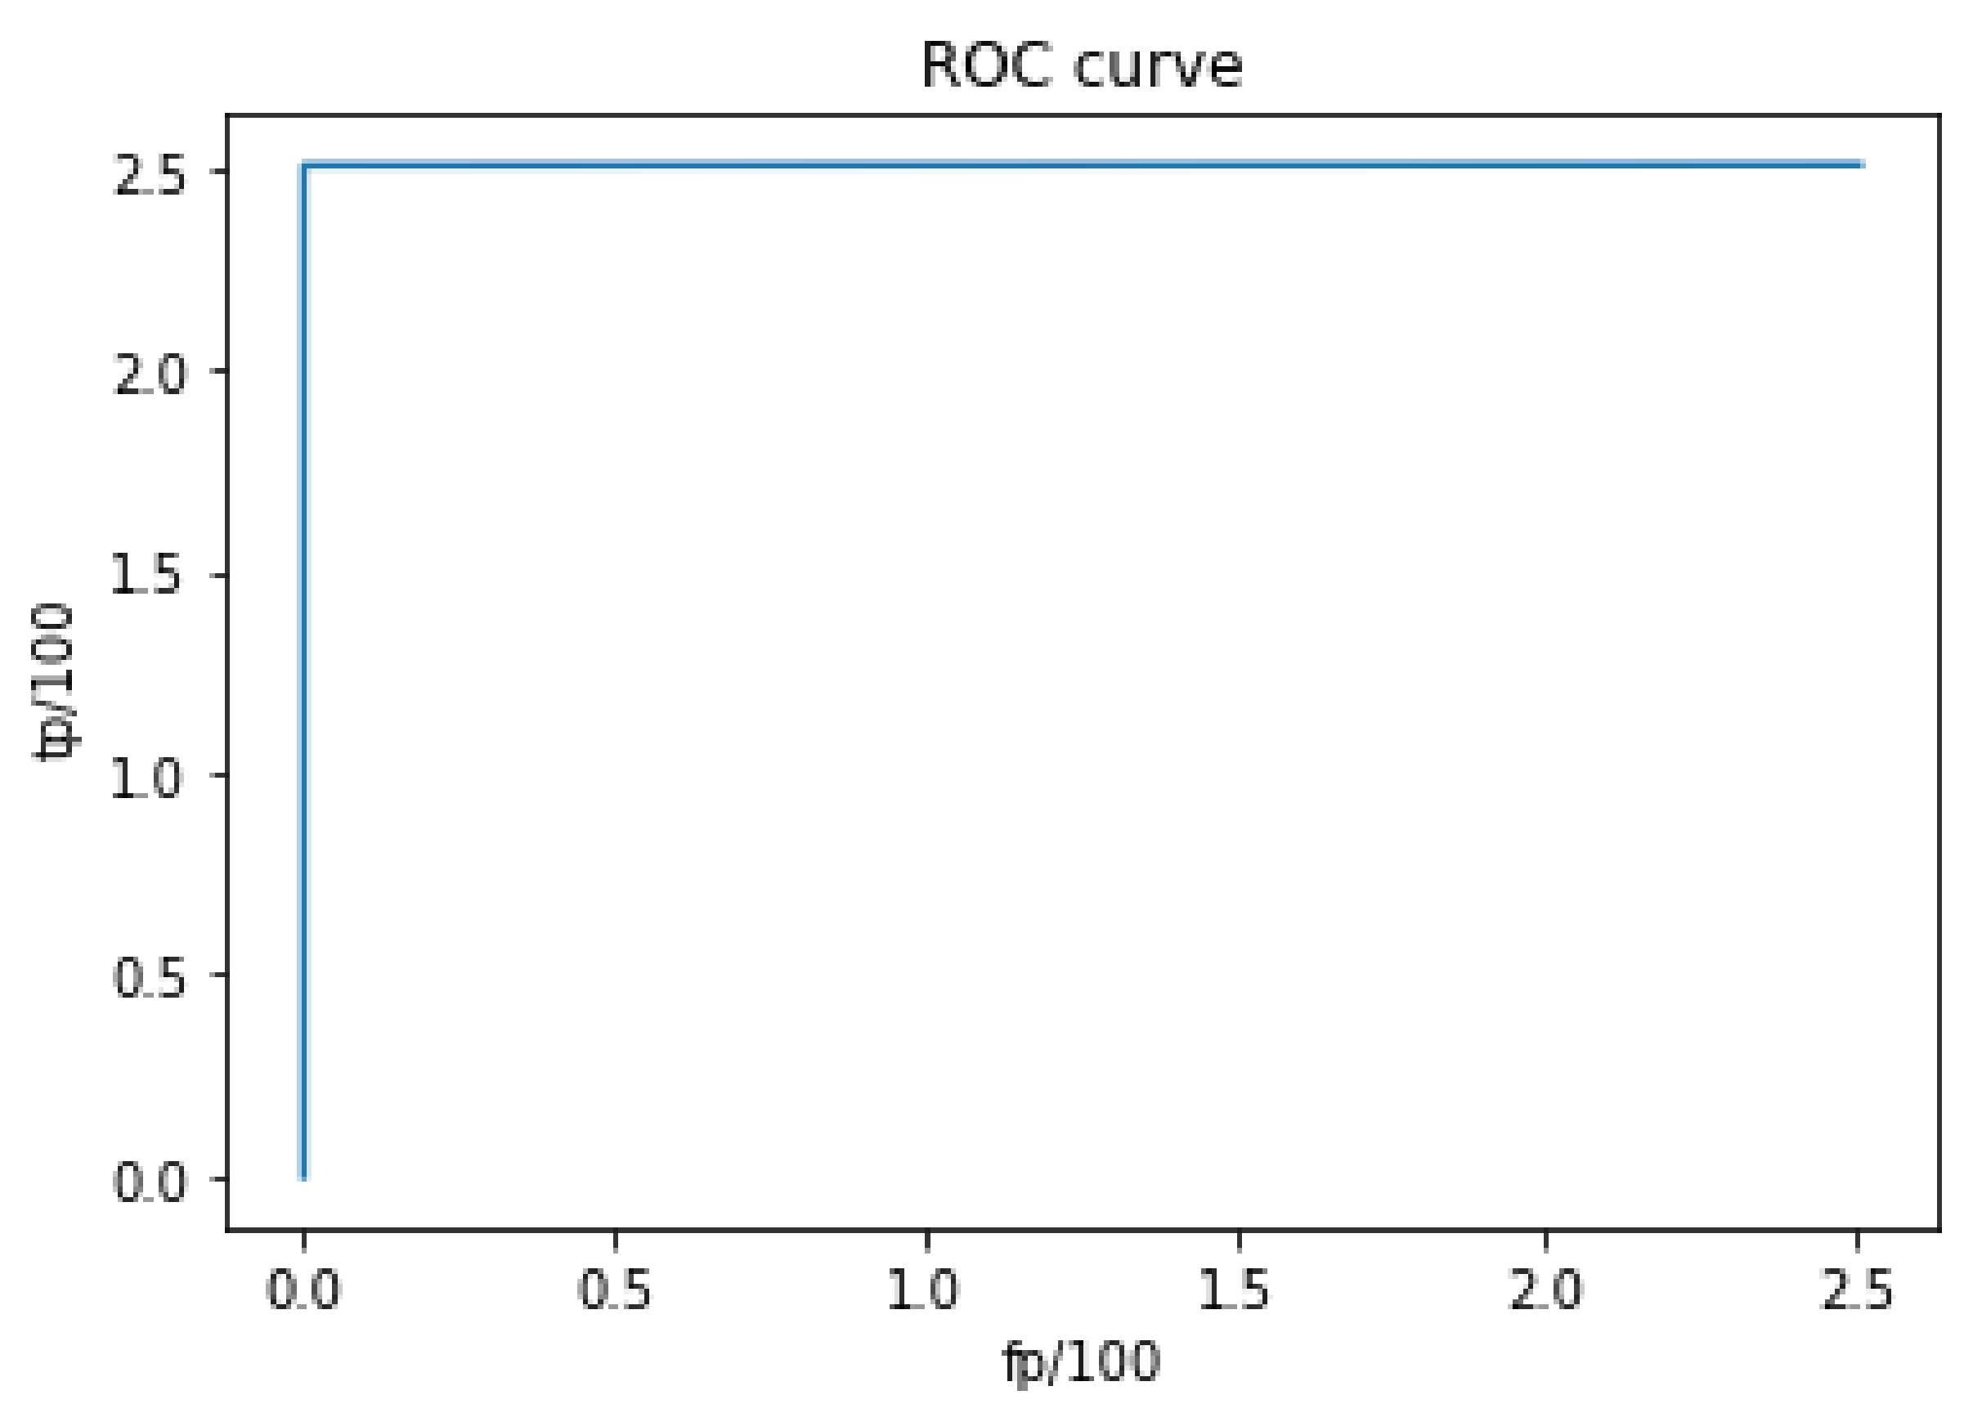

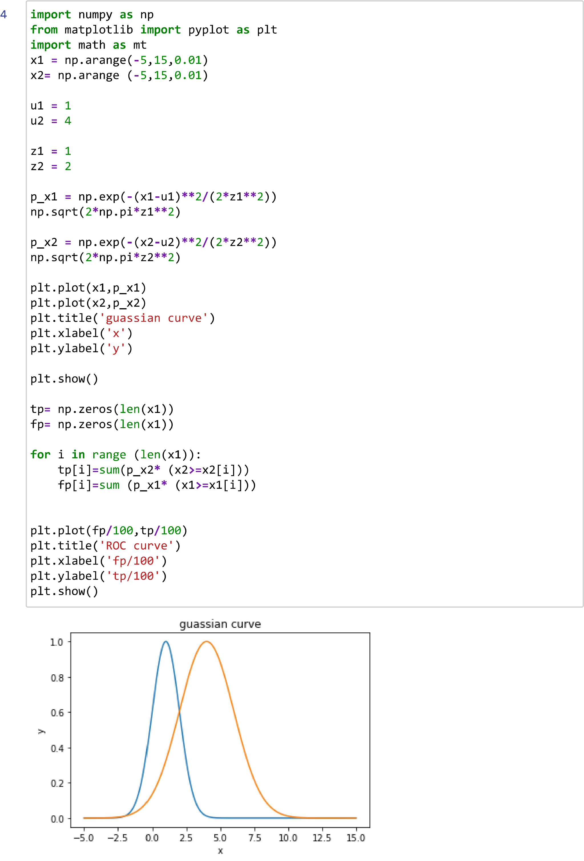

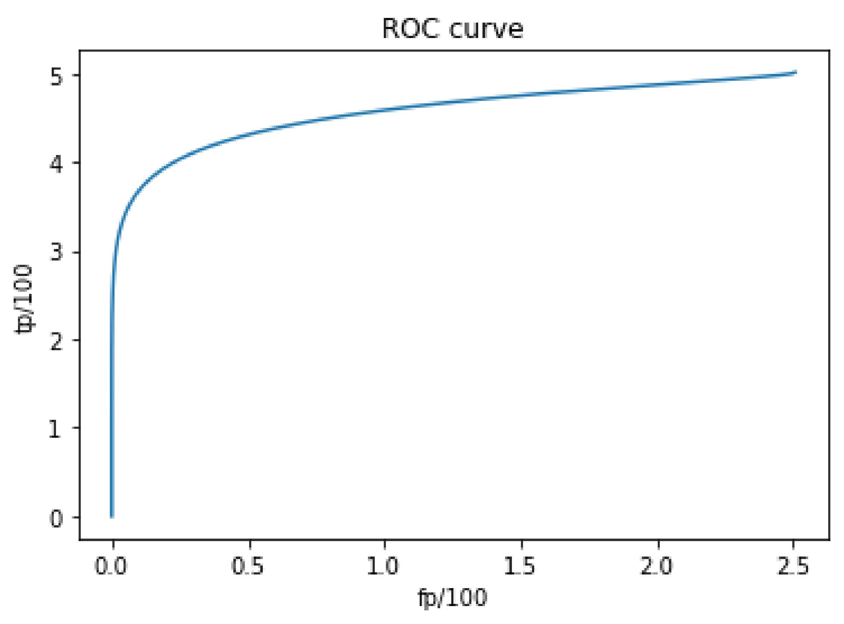

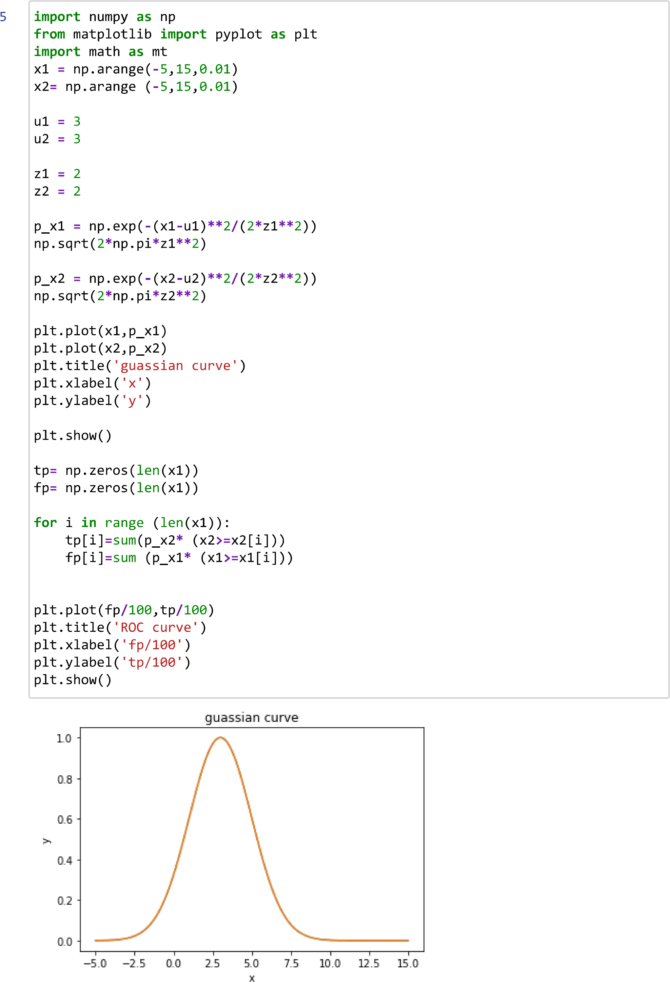

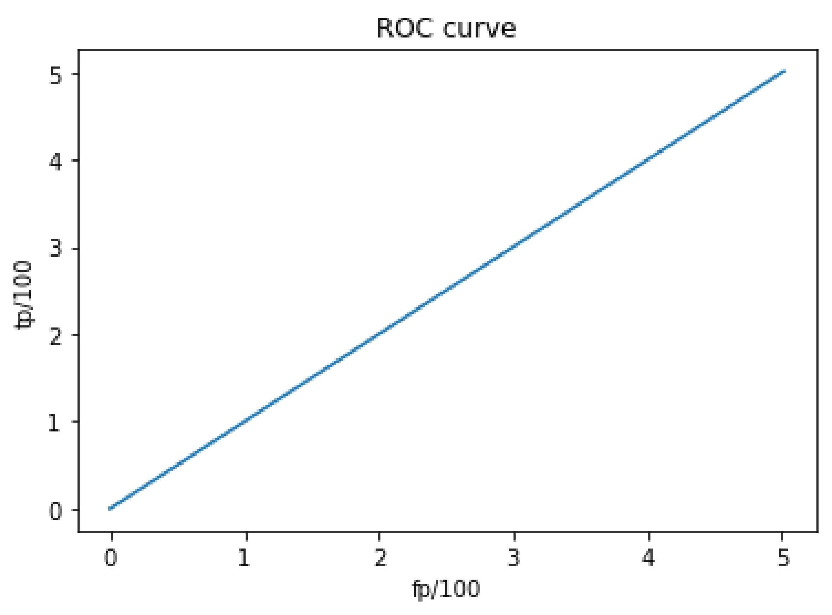

MACHINE LEARNING PRACTICAL NUMBER - 8

Name : Kadam Kiran Prakashrao

Reg. No. : 2019BEC147

Roll No. A71

**Aim : Write a python program for Multivariate Regression Modeling.**

**1. Consider the attached dataset of power consumption containing (4 rows and 3 column). De ne the function for computing the regression coe cients. Print out the coe cients.**

import matplotlib.pyplot as plt

import numpy as np import pandas

as pd

y = np.array([[0.5, 2.5, 2.2, 1.8]]).T x1

= np.array([[10, 5, 4.5, 6]]).T x2

= np.array([[2, 42, 31, 35]]).T

X = np.array([[1, 10, 2], [1, 5, 42], [1, 4.5, 31], [1, 6, 35]]) bita

= np.dot(np.linalg.inv(np.dot(X.T,X)),np.dot(X.T,y))

B0, B1, B2 = bita print(f'B0

= {B0[0]}') print(f'B1 =

{B1[0]}') print(f'B2 =

{B2[0]}')

B0 = 2.4976158809911055

B1 = -0.2075168710900943

B2 = 0.02092015171666417

1. **De ne the function for computing energy consumption for given regression coe cients as inputs as follows. Print the output describing energy required (KW) for given temp and no. of persons. I. temp =**

**7.5 and No. of persons in room = 131 II. temp = 3.5 and No. of persons in room = 45 III. temp = 7.2 and No. of persons in room = 27**

Energy Conservation - 7.5 degree Temprature and 131 peoples is - [3.68177922] kw

Energy Conservation - 3.5 degree Temprature and 45 peoples is - [2.71271366] kw

}

import matplotlib.pyplot as plt

import numpy as np import pandas

as pd

def EnerCons(Temp, Peoples): y = np.array([[0.5, 2.5, 2.2, 1.8]]).T x1

= np.array([[10, 5, 4.5, 6]]).T x2

= np.array([[2, 42, 31, 35]]).T

X = np.array([[1, 10, 2], [1, 5, 42], [1, 4.5, 31], [1, 6, 35]]) bita = np.dot(np.linalg.inv(np.dot(X.T,X)),np.dot(X.T,y)) B0, B1, B2 = bita y = B0 + B1 * Temp + B2 * Peoples print(f'Energy Conservation - {Temp} degree Temprature and {Peoples

EnerCons(7.5, 131)

EnerCons(3.5, 45)

EnerCons(7.2, 27)

Energy Conservation - 7.2 degree Temprature and 27 peoples is - [1.56833851] kw

1. **Plot the 3D graph for power consumption data using multivariate regression coe cients. ( t the**

import matplotlib.pyplot as plt

import numpy as np import pandas

as pd

x1 = np.linspace(-20,20,50) x2 = np.linspace(-20,200,10) X1, X2 = np.meshgrid(x1, x2) Y = B0 + B1 * X1 + B2 * X2 fig = plt.figure() ax = plt.axes(projection='3d') ax.plot_surface(X1,

X2, Y, cmap='Greens') ax.set_xlabel('Outside Temp') ax.set_ylabel('No. of peoples in room') ax.set_zlabel('Power (KW)')

ax.set_title('Multivariate Regression')

**hyperplane)**

Text(0.5, 0.92, 'Multivariate Regression')

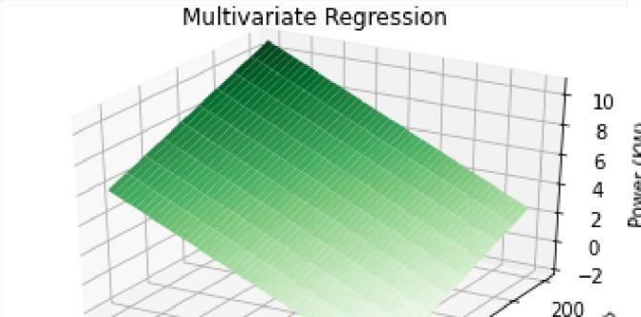

1. **Read the attached insur-2d.csv le using Pandas library. Compute the multivariate regression coe cient for given csv le data. Print the coe cients.**

B0 = 5.334690518256983

B1 = 0.02211231633473454

|  |
| --- |
| import matplotlib.pyplot as plt  import numpy as np import pandas  as pd  def EnerCons(Temp, Peoples, X, y): bita =  np.dot(np.linalg.inv(np.dot(X.T,X)),np.dot(X.T,y)) B0, B1, B2 = bita  y = B0 + B1 * Temp + B2 * Peoples  print(f'Energy Conservation - {Temp} degree Temprature and {Peoples data = pd.read_csv('insur-2d.csv', header=None) data = data.to_numpy() a = [] b = [] for i in data: a.append([i[2]])  b.append([1,float(i[0]),i[1]]) y = np.array(a) X  = np.array(b) |

|  |
| --- |
| import matplotlib.pyplot as plt  import numpy as np import pandas  as pd data = pd.read_csv('insur-2d.csv', header=None) data = data.to_numpy() a = [] b = [] for i in data: a.append([i[2]])  b.append([1,float(i[0]),i[1]]) y = np.array(a) X = np.array(b) bita = np.dot(np.linalg.inv(np.dot(X.T,X)),np.dot(X.T,y)) B0, B1, B2 = bita print(f'B0 = {B0[0]}') print(f'B1 =  {B1[0]}') print(f'B2 = {B2[0]}') |

B2 = -0.007797493927085619

1. **Predict the three outputs for unknown three pair of inputs.**

( , , , y)



}



EnerCons(7.5, 131, X, y)

EnerCons(3.5, 45, X, y)

EnerCons(7.2, 27, X, y)

Energy Conservation - 7.5 degree Temprature and 131 peoples is : [4.47906119] kw

Energy Conservation - 3.5 degree Temprature and 45 peoples is : [5.0611964] kw

|  |
| --- |
| import matplotlib.pyplot as plt  import numpy as np import pandas  as pd  bita = np.dot(np.linalg.inv(np.dot(X.T,X)),np.dot(X.T,y)) B0, B1, B2 = bita x1 = np.linspace(-2,20,50) x2 =  np.linspace(-20,1000,10) X1, X2 = np.meshgrid(x1, x2) Y =  B0 + B1 * X1 + B2 * X2 fig = plt.figure() ax  = plt.axes(projection='3d') ax.plot_surface(X1, X2, Y, cmap='Greens') ax.set_title('Multivariate Regression') |

Energy Conservation - 7.2 degree Temprature and 27 peoples is : [5.28336686] kw

1. **Plot the 3D graph for given data of csv le using multivariate regression coe cients. ( t the hyperplane)** Text(0.5, 0.92, 'Multivariate Regression')

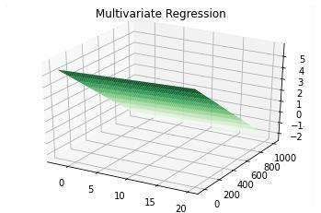

**Conclusion :** In this practical Multivariate Regression Modelling was studied and performed using python.



1



s



completed at 22:52



**Practical No:09**

**Name: Kadam Kiran Prakashrao**

**Roll No: A71**

**Reg No: 2019BEC147**

**Sub: ML**

import numpy as np import matplotlib.pyplot as plt import pandas as pd

**Create an own dataset containing (150 random values for input and output) using numpy library. Define the function for computing regression coefficients using gradient descent.**

**(consider c=0.001, b0=0.5, b1=1.3, E=0, Emax=0.001 and epochs=5000)**

def Descent_Gradiant(x,y,E_max,E,C,b0,b1,epochs):

plt.scatter(x,y) y_new=np.array(np.zeros(len(x)));

for j in range(epochs): for i in range(len(x)): y_new[i]=b0+b1*x[i];

E=(y[i]-y_new[i])**2;

if E> E_max:

b0=C*(y[i]-y_new[i]); b1=b1+C*(y[i]-y_new[i])*x[i];

plt.plot(x,y_new,color="red")

# for c=0.001, b0=0.5, b1=1.3, E=0, Emax=0.001 and epochs=5000 x=2*np.random.rand(150,1) y=5*x+3*np.random.rand(150,1)

E_max=0.001

E=0 C=0.01 epochs=5000

b0=0.5 b1=1.3

Descent_Gradiant(x,y,E_max,E,C,b0,b1,epochs)

**Output:**

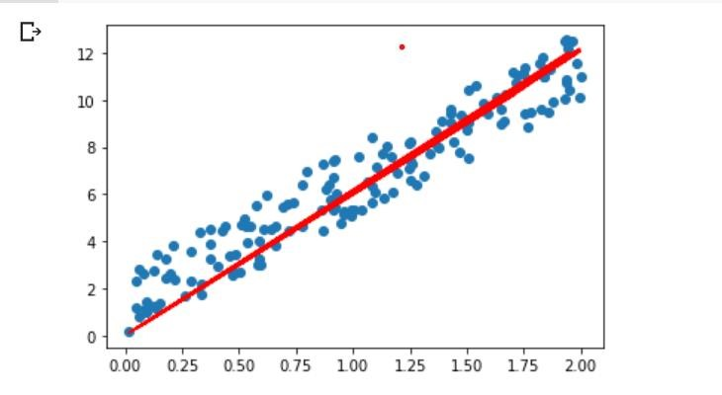

**Print the coefficients. Plot (scatter) the input and output data. Also plot the linear regression line using coefficients.**

from math import inf def Descent_Gradiant(x,y,E_max,E,C,b0,b1,epochs):

plt.scatter(x,y) y_new=np.array(np.zeros(len(x)));

for j in range(epochs): for i in range(len(x)): y_new[i]=b0+b1*x[i];

E=(y[i]-y_new[i])**2;

if E> E_max and E!=inf: b0=C*(y[i]-y_new[i]); b1=b1+C*(y[i]-y_new[i])*x[i];

plt.plot(x,y_new,color="red") print(f"Bita_0={b0}") print(f"Bita_1={b1}")

# for c=0.001, b0=0.5, b1=1.3, E=0, Emax=0.001 and epochs=5000 x=2*np.random.rand(200,1) y=5*x+3*np.random.rand(200,1)

E_max=0.001

E=0 C=0.01 epochs=5000 b0=0.5 b1=1.3 Descent_Gradiant(x,y,E_max,E,C,b0,b1,epochs)

Output:

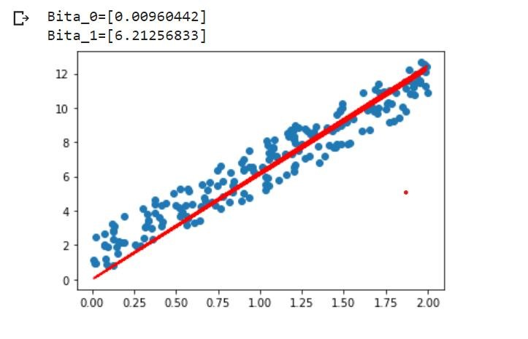

**Compute the linear regression coefficients using gradient descent function for given data and print it for various learning constant (0.001, 0.005, 0.01,0.05) and various epochs (1000, 2000, 3000, 5000). Also print the regression line for various learning constant and various epochs.**

**For C=0.001 & epochs=1000**

x=2*np.random.rand(200,1) y=5*x+3*np.random.rand(200,1)

E_max=0.001

E=0 C=0.001 epochs=1000

b0=0.5 b1=1.3

Descent_Gradiant(x,y,E_max,E,C,b0,b1,epochs) Output:

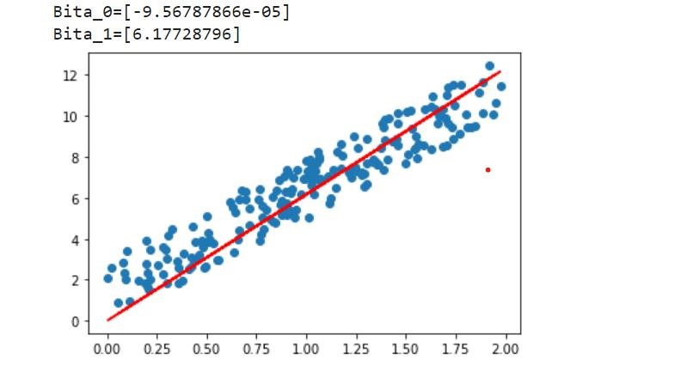

**For C=0.005 & epochs=2000**

x=2*np.random.rand(200,1) y=5*x+3*np.random.rand(200,1)

E_max=0.001

E=0 C=0.005 epochs=2000 b0=0.5 b1=1.3

Descent_Gradiant(x,y,E_max,E,C,b0,b1,epochs) **Output:**

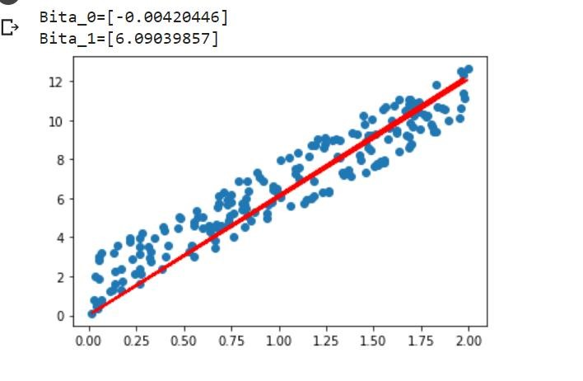

**For C=0.01 & epochs=3000**

x=2*np.random.rand(200,1) y=5*x+3*np.random.rand(200,1)

E_max=0.001

E=0 C=0.01 epochs=3000 b0=0.5 b1=1.3

Descent_Gradiant(x,y,E_max,E,C,b0,b1,epochs) **Output:**

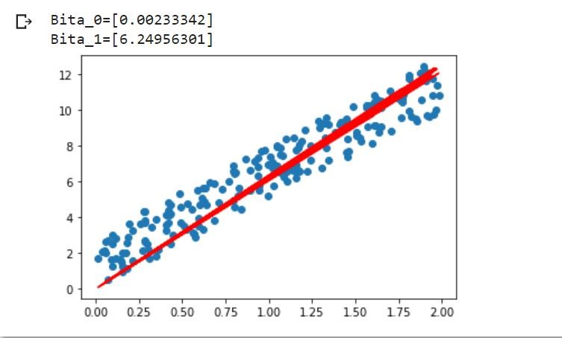

**For C=0.05 & epochs=5000**

x=2*np.random.rand(200,1) y=5*x+3*np.random.rand(200,1)

E_max=0.001

E=0 C=0.05 epochs=5000 b0=0.5 b1=1.3

Descent_Gradiant(x,y,E_max,E,C,b0,b1,epochs) **Output:**

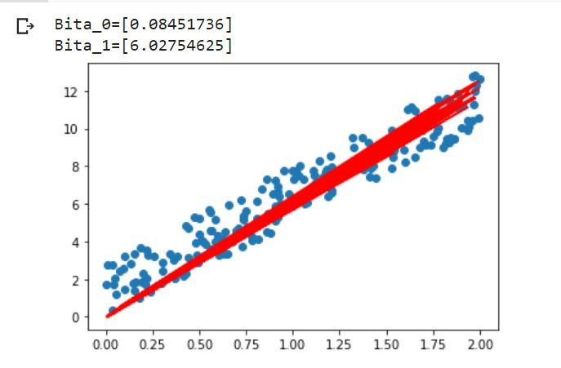

**Read the attached insu.csv file using Pandas library. Find the linear regression coefficients using gradient descent for given file and print the coefficients. (Initialize the value as per your convenience)**

from math import inf def Descent_Gradiant(x,y,E_max,E,C,b0,b1,epochs):

y_new=np.array(np.zeros(len(x)));

for j in range(epochs): for i in range(len(x)): y_new[i]=b0+b1*x[i];

E=(y[i]-y_new[i])**2;

if E> E_max and E!=inf: b0=C*(y[i]-y_new[i]); b1=b1+C*(y[i]-y_new[i])*x[i];

print(f"Bita_0={b0}") print(f"Bita_1={b1}")

data=pd.read_csv("/content/insu (1).csv") x=np.array([data['X_Data']]) y=np.array([data['Y']])

x=x.T y=y.T

E_max=0.001

E=0 C=0.005 epochs=5000

b0=1.5 b1=0.5

Descent_Gradiant(x,y,E_max,E,C,b0,b1,epochs) Output:

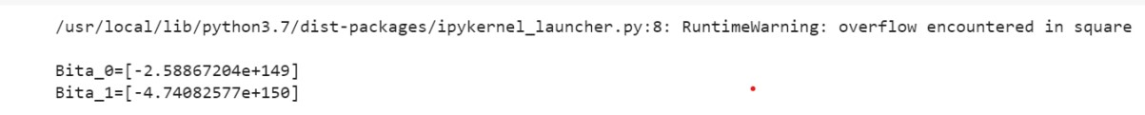

**Plot the variables containing the values from csv file. Also plot the linear regression line using coefficients.**

from math import inf def Descent_Gradiant(x,y,E_max,E,C,b0,b1,epochs):

y_new=np.array(np.zeros(len(x)));

for j in range(epochs): for i in range(len(x)): y_new[i]=b0+b1*x[i];

E=(y[i]-y_new[i])**2;

if E> E_max and E!=inf: b0=C*(y[i]-y_new[i]); b1=b1+C*(y[i]-y_new[i])*x[i];

plt.subplot(1,2,2) plt.plot(x,y_new,color='red') print(f"Bita_0={b0}") print(f"Bita_1={b1}")

data=pd.read_csv("/content/insu (1).csv")

x=np.array([data['X_Data']]) y=np.array([data['Y']])

x=x.T y=y.T

E_max=0.01

E=0 C=0.05 epochs=1000

b0=0.5 b1=1.3 b0 = np.float128(b0) b1 = np.float128(b1) plt.subplot(1,2,1) plt.scatter(x,y)

Descent_Gradiant(x,y,E_max,E,C,b0,b1,epochs) Output:

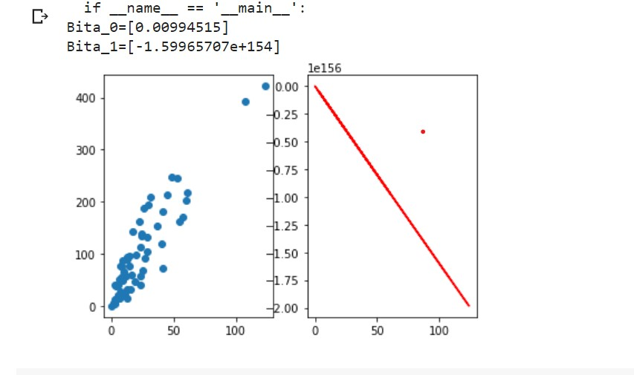

**Check the coefficient values computed by co-variance method and gradient descent method for insu.csv file.*italicized text\***

from math import inf def Descent_Gradiant(x,y,E_max,E,C,b0,b1,epochs):

y_new=np.array(np.zeros(len(x)));

for j in range(epochs): for i in range(len(x)): y_new[i]=b0+b1*x[i];

E=(y[i]-y_new[i])**2;

if E> E_max and E!=inf: b0=C*(y[i]-y_new[i]); b1=b1+C*(y[i]-y_new[i])*x[i];

print(f"Bita_0={b0}") print(f"Bita_1={b1}")

x=2*np.random.rand(200,1) y=5*x+3*np.random.rand(200,1)

E_max=0.01

E=0 C=0.05 epochs=1000

b0=0.5 b1=1.3 b0 = np.float128(b0) b1 = np.float128(b1)

Descent_Gradiant(x,y,E_max,E,C,b0,b1,epochs) Output:



**Find the predicted output for unknown input values using linear regression coefficients and print it. (for insu.csv dataset)**

from math import inf def Descent_Gradiant(x,y,E_max,E,C,b0,b1,epochs,input):

y_new=np.array(np.zeros(len(x)));

for j in range(epochs): for i in range(len(x)): y_new[i]=b0+b1*x[i];

E=(y[i]-y_new[i])**2;

if E> E_max and E!=inf: b0=C*(y[i]-y_new[i]); b1=b1+C*(y[i]-y_new[i])*x[i];

y_pred=b0+b1*input;

print(f"Predicted output = {y_pred} for the input = {input}")

data=pd.read_csv("/content/insu (1).csv") x=np.array([data['X_Data']]) y=np.array([data['Y']])

x=x.T y=y.T x=2*np.random.rand(200,1) y=2*x+3*np.random.rand(200,1)

E_max=0.01

E=0 C=0.05 epochs=1000

b0=0.5 b1=1.3

Descent_Gradiant(x,y,E_max,E,C,b0,b1,epochs,5.10)

Descent_Gradiant(x,y,E_max,E,C,b0,b1,epochs,10.90)

Descent_Gradiant(x,y,E_max,E,C,b0,b1,epochs,50.10)

Descent_Gradiant(x,y,E_max,E,C,b0,b1,epochs,5.10) Output:

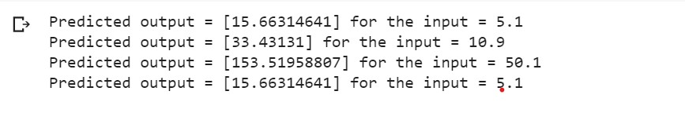

Name :- Kadam Kiran Prakashrao

Reg no. 2019BEC147

Roll no. A71

Subj:- ML_P_10

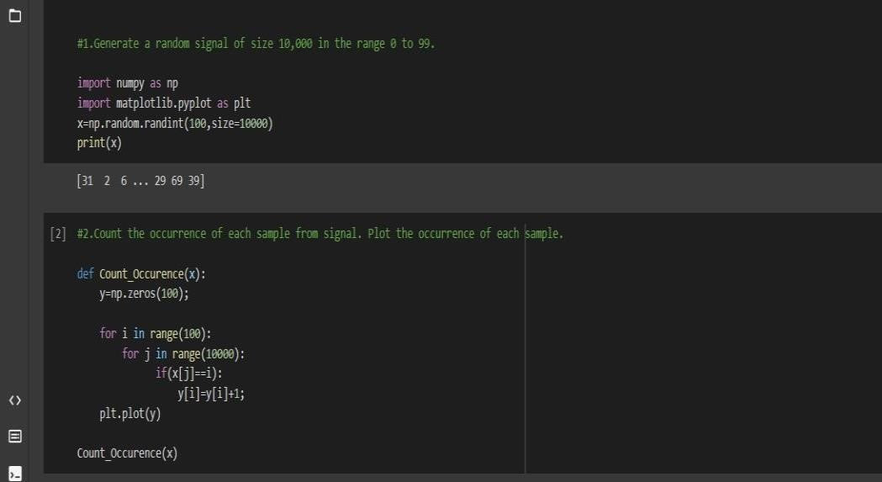

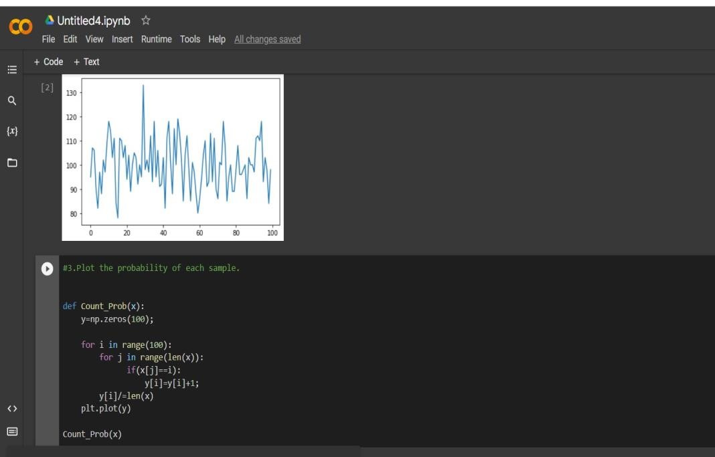

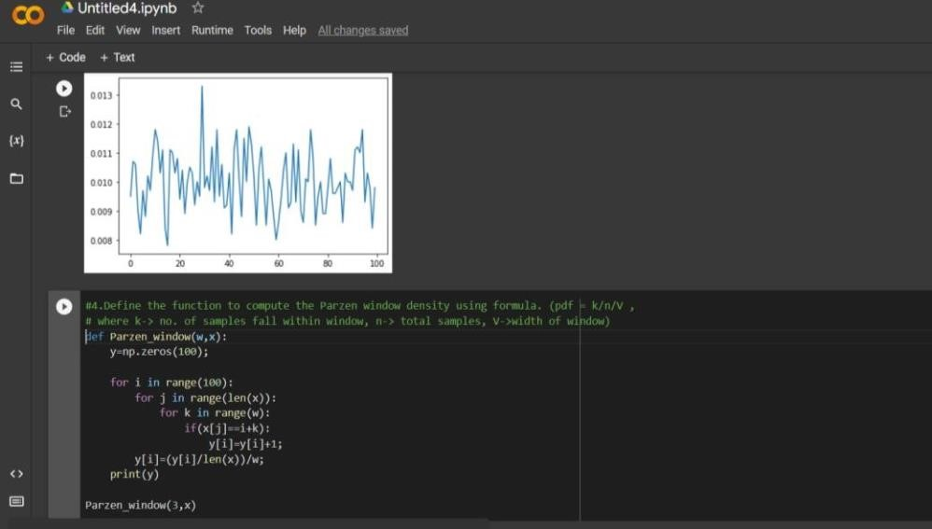

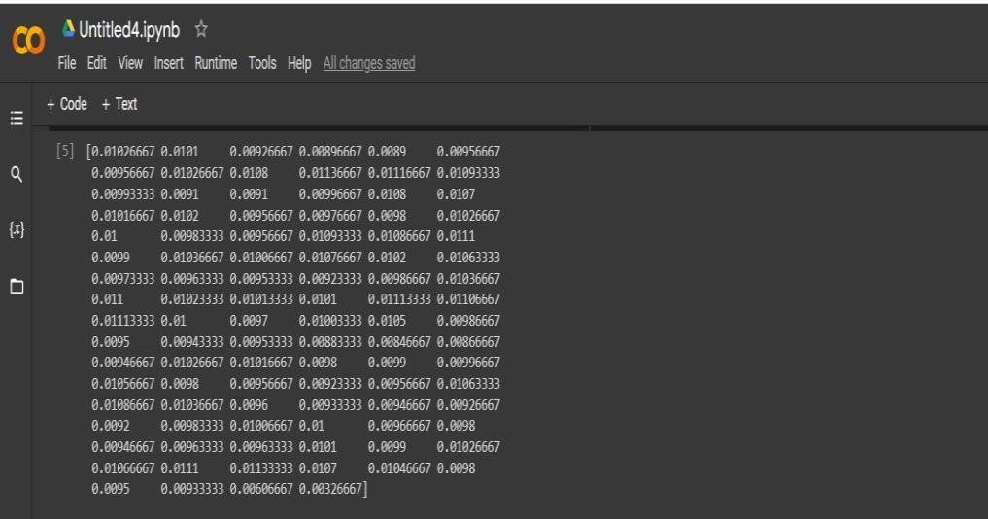

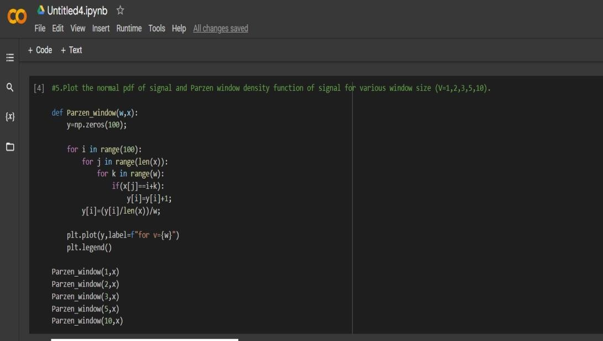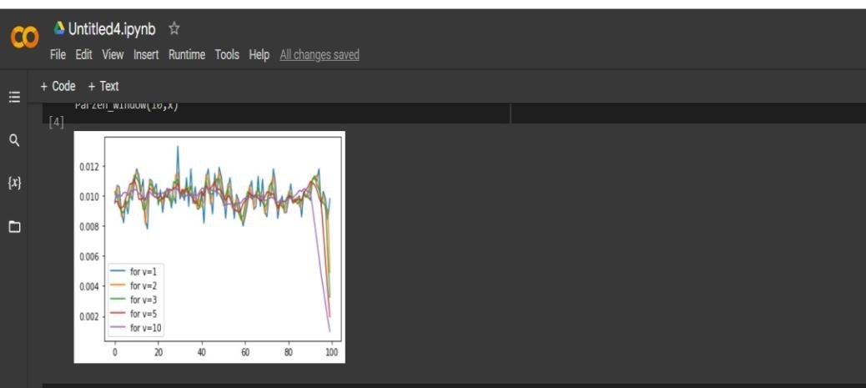

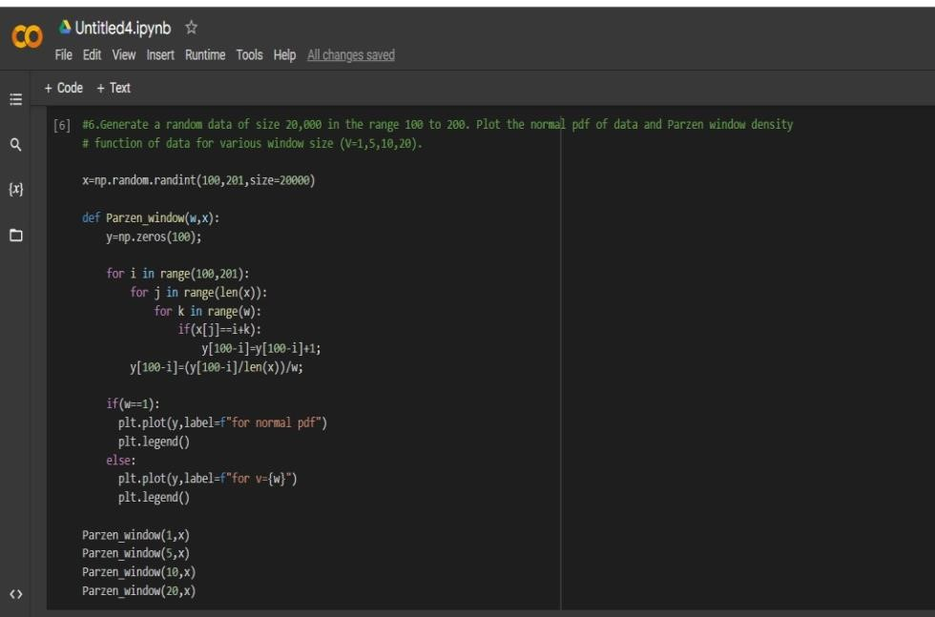

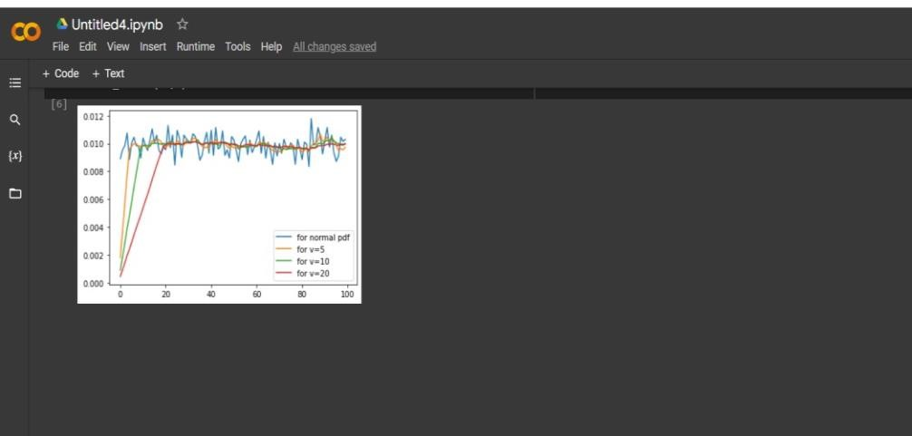

Kadam Kiran Prakashrao

2019

BEC

147

A71

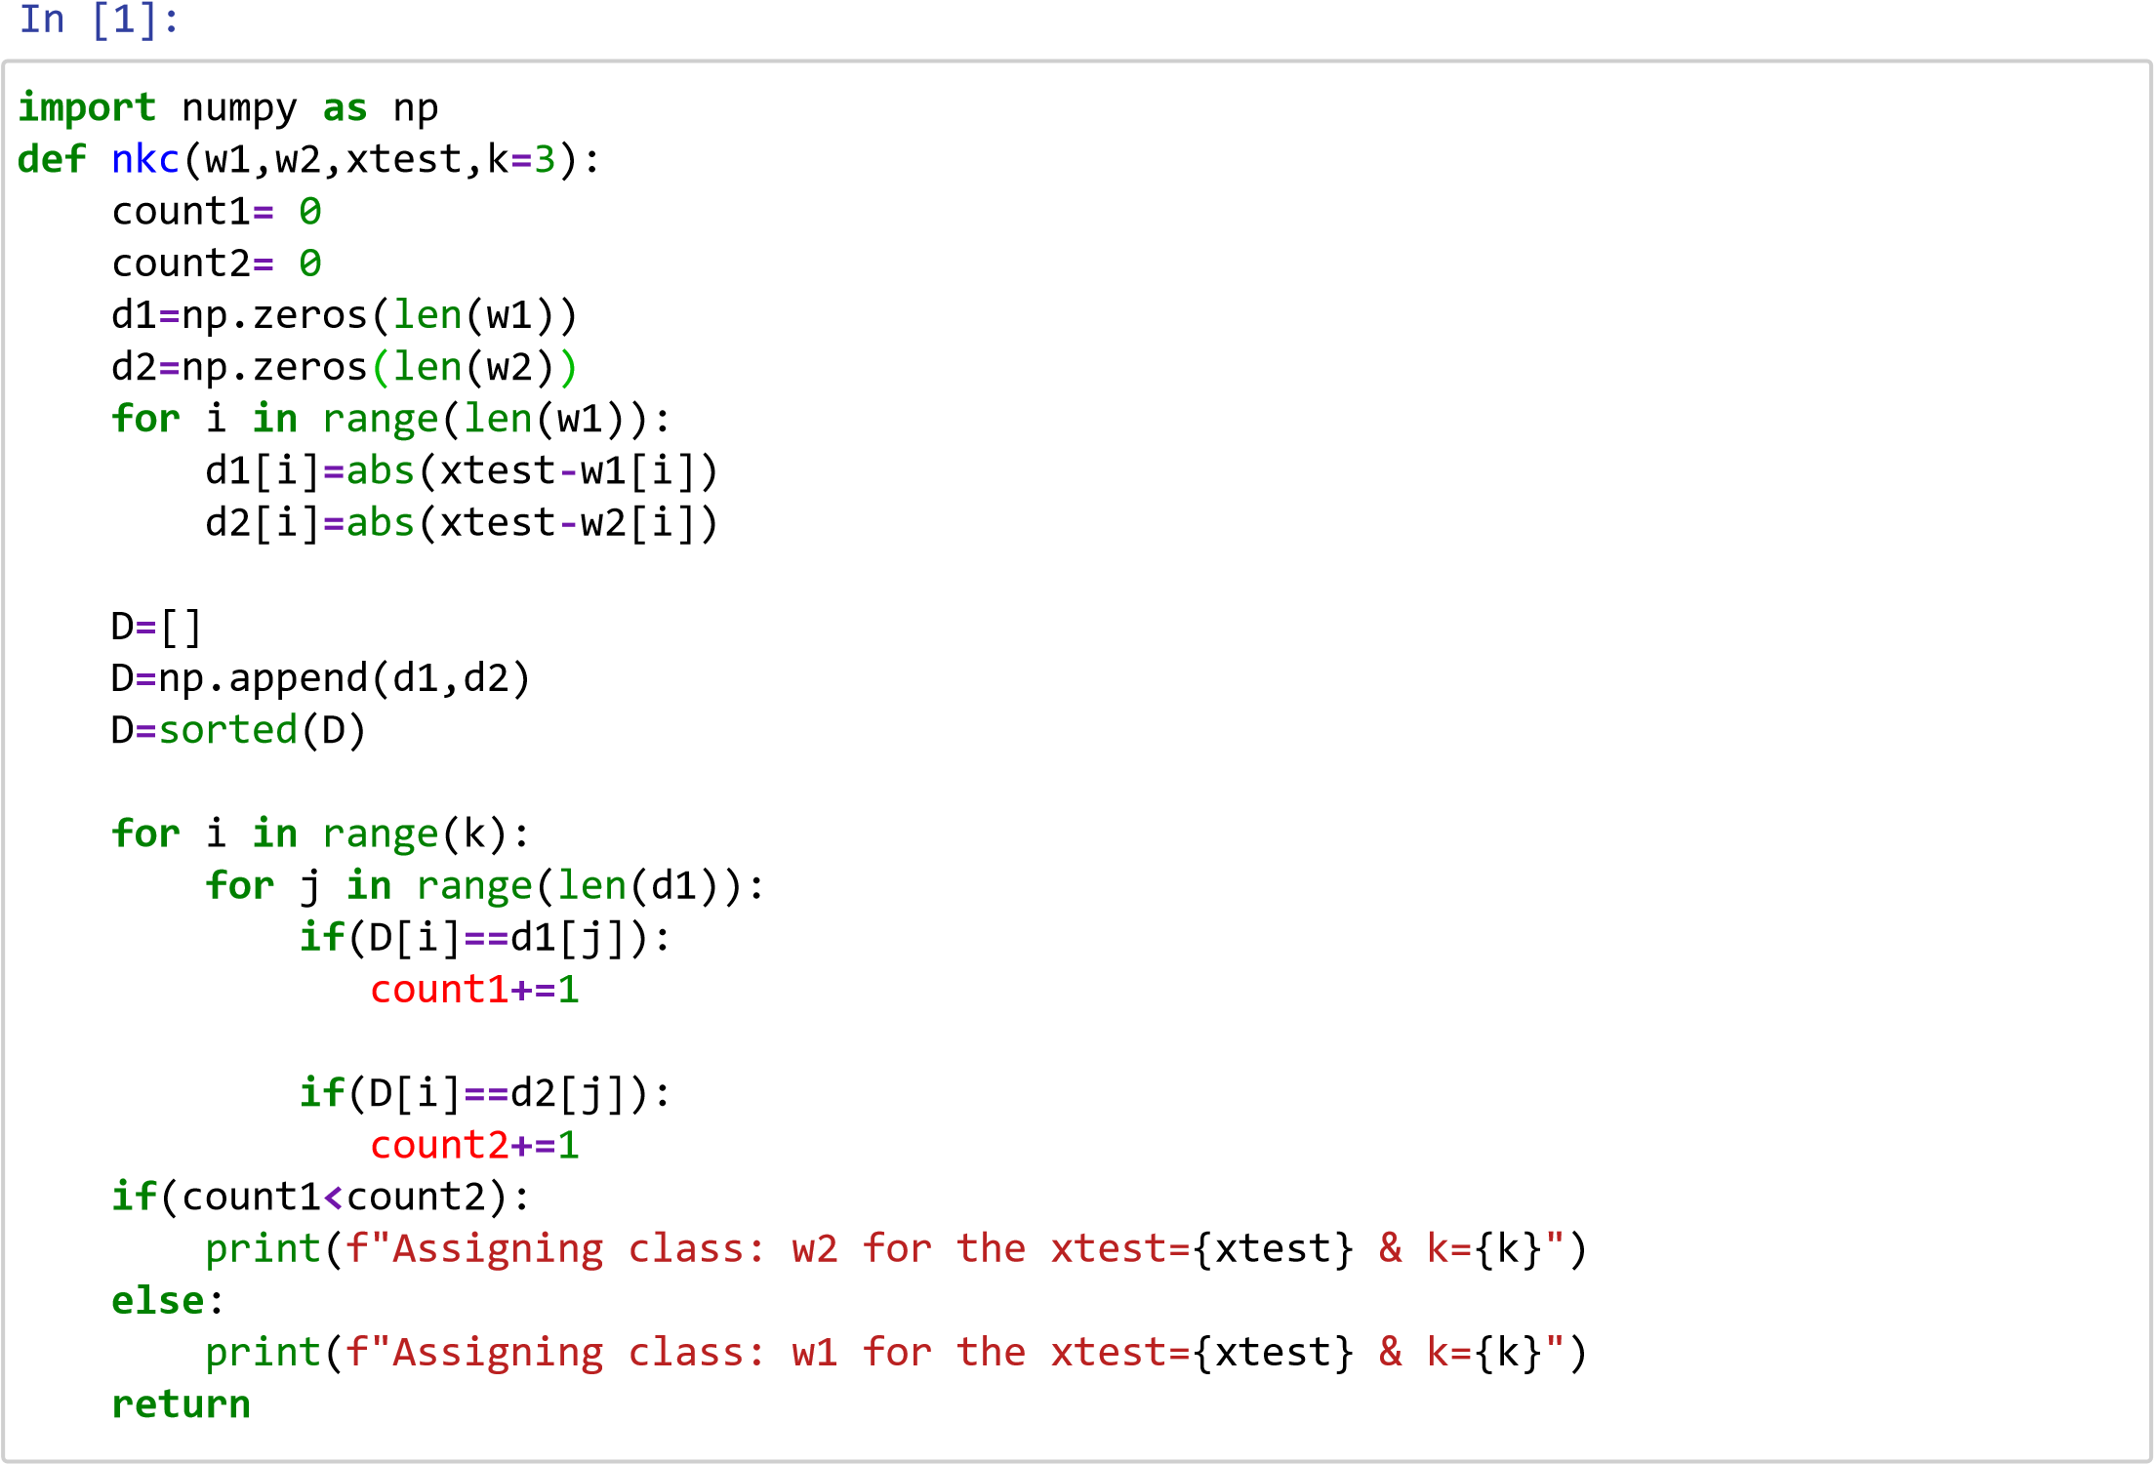

[2]:

Assigning class: w1 for the xtest=3.3 & k=3

Assigning class: w1 for the xtest=3.3 & k=5

w1

**=**

[

1.4

,

3.6

,

4.7

,

2.8

,

7.4

,

5.3

,

6.7

,

3.2

,

4.8

]

w2

**=**

[

4.5

,

3.7

,

2.4

,

7.8

,

9.3

,

7.0

,

6.4

,

8.3

,

5.1

]

nkc

(

w1

,

w2

,

3.3

)

nkc

(

w1

,

w2

,

3.3

,

5

)

nkc

(

w1

,

w2

,

3.3

,

7

)

nkc

(

w1

,

w2

,

1.9

)

nkc

(

w1

,

w2

,

1.9

,

5

)

nkc

(

w1

,

w2

,

1.9

,

7

)

nkc

(

w1

,

w2

,

8.6

)

nkc

(

w1

,

w2

,

8.6

,

5

)

nkc

(

w1

,

w2

,

8.6

,

7

)

nkc

(

w1

,

w2

,

4.1

)

nkc

(

w1

,

w2

,

4.1

,

5

)

nkc

(

w1

,

w2

,

4.1

,

7

)

Assigning class: w1 for the xtest=3.3 & k=7

Assigning class: w1 for the xtest=1.9 & k=3

Assigning class: w1 for the xtest=1.9 & k=5

Assigning class: w1 for the xtest=1.9 & k=7

Assigning class: w2 for the xtest=8.6 & k=3

Assigning class: w2 for the xtest=8.6 & k=5

Assigning class: w2 for the xtest=8.6 & k=7

Assigning class: w2 for the xtest=4.1 & k=3

Assigning class: w1 for the xtest=4.1 & k=5

Assigning class: w1 for the xtest=4.1 & k=7

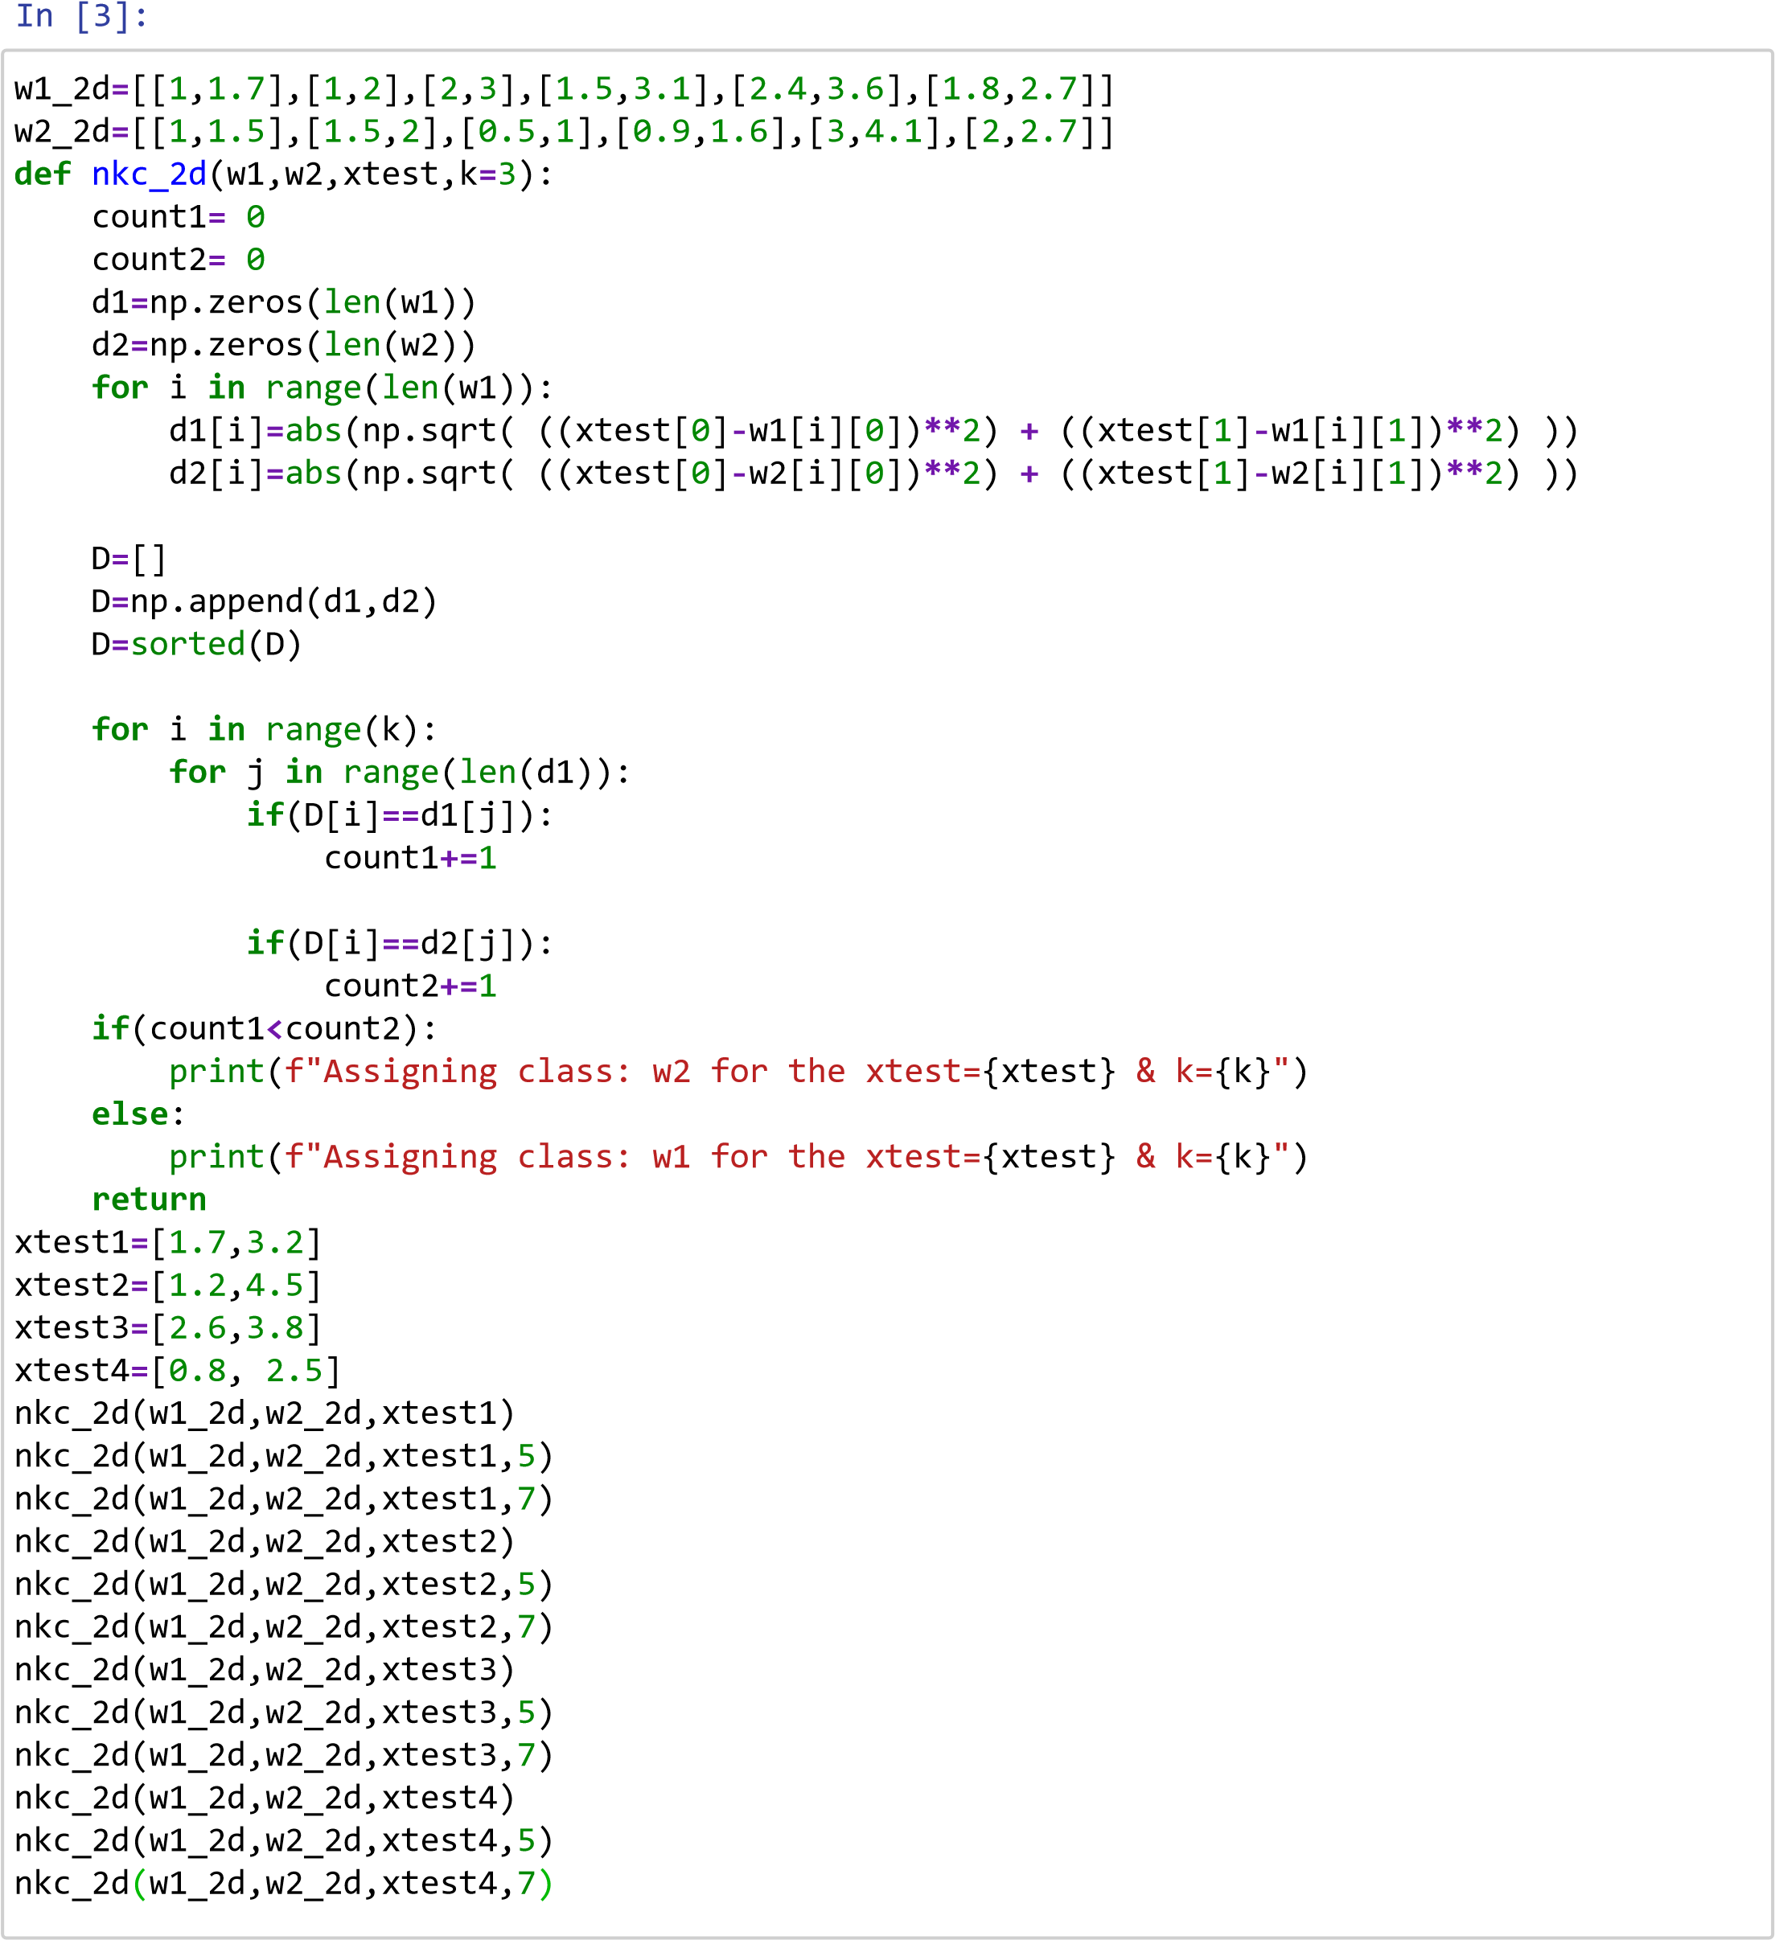

Assigning class: w1 for the xtest=[1.7, 3.2] & k=3

Assigning class: w1 for the xtest=[1.7, 3.2] & k=5

Assigning class: w1 for the xtest=[1.7, 3.2] & k=7

Assigning class: w1 for the xtest=[1.2, 4.5] & k=3

Assigning class: w1 for the xtest=[1.2, 4.5] & k=5

Assigning class: w1 for the xtest=[1.2, 4.5] & k=7

Assigning class: w1 for the xtest=[2.6, 3.8] & k=3

Assigning class: w1 for the xtest=[2.6, 3.8] & k=5

Assigning class: w1 for the xtest=[2.6, 3.8] & k=7

Assigning class: w1 for the xtest=[0.8, 2.5] & k=3

Assigning class: w1 for the xtest=[0.8, 2.5] & k=5

Assigning class: w1 for the xtest=[0.8, 2.5] & k=7 Assigning class: w2 for the xtest=0.12981624216735974 & k=3

Assigning class: w1 for the xtest=0.12981624216735974 & k=5

Assigning class: w1 for the xtest=0.12981624216735974 & k=7

Assigning class: w2 for the xtest=0.0020216395121142395 & k=3

Assigning class: w2 for the xtest=0.0020216395121142395 & k=5

Assigning class: w1 for the xtest=0.0020216395121142395 & k=7

Assigning class: w1 for the xtest=0.012418376390682571 & k=3

Assigning class: w1 for the xtest=0.012418376390682571 & k=5

[4]:

w1_r

**=**

0.35

**\***

np

.

random

.

rand

(

100

)

w2_r

**=**

0.74

**\***

np

.

random

.

rand

(

100

)

r

**=**

0.14

**\***

np

.

random

.

rand

(

5

)

**for**

i

**in**

range

(

5

):

nkc

(

w1_r

,

w2_r

,

r

[

i

])

nkc

(

w1_r

,

w2_r

,

r

[

i

]

,

5

)

nkc

(

w1_r

,

w2_r

,

r

[

i

]

,

7

)

Assigning class: w1 for the xtest=0.012418376390682571 & k=7

Assigning class: w1 for the xtest=0.059033150168201425 & k=3

Assigning class: w1 for the xtest=0.059033150168201425 & k=5

Assigning class: w1 for the xtest=0.059033150168201425 & k=7

Assigning class: w2 for the xtest=0.12281924256161703 & k=3

Assigning class: w2 for the xtest=0.12281924256161703 & k=5

Assigning class: w2 for the xtest=0.12281924256161703 & k=7

Kadam Kiran Prakashrao

2019

BEC

147

A71

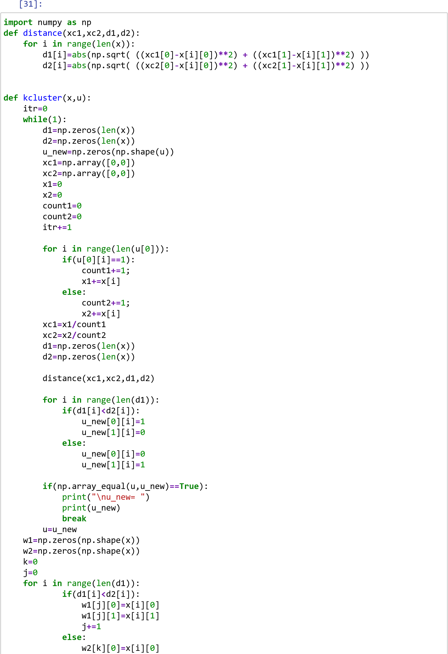

In

[32]:

w2

[

k

][

1

]

**=**

x

[

i

][

1

]

k

**+=**

1

print

(

'\nw1='

,

w1

)

print

(

'\nw2='

,

w2

)

print

(

'\niteraation ='

,

itr

)

x

**=**

np

.

array

([[

3

,

1

]

,

[

4

,

2

]

,

[

1

,

1

]

,

[

6

,

3

]

,

[

2

,

6

]

,

[

**-**

1

,

2

]])

u

**=**

np

.

array

([[

0

,

0

,

1

,

1

,

0

,

0

]

,

[

1

,

1

,

0

,

0

,

1

,

1

]])

kcluster

(

x

,

u

)

u_new= [[1. 1. 0. 1. 0. 0.]

[0. 0. 1. 0. 1. 1.]]

w1= [[3. 1.]

[4. 2.]

[6. 3.]

[0. 0.]

[0. 0.]

[0. 0.]]

w2= [[ 1. 1.]

[ 2. 6.]

[-1. 2.]

[ 0. 0.]

[ 0. 0.]

[ 0. 0.]] iteraation = 2

[33]:

x**=**np.array([[**-**1,1],[**-**2, **-**3],[1, 3],[**-**2, 1],[5, 1],[4, **-**2],[3, **-**1],[3 3]]) u**=**np.array([[1, 0, 0, 1, 0, 0, 1, 1], [0, 1, 1, 0, 1, 1, 0, 0]]) kcluster(x,u)

u_new=

[[1. 0. 1. 1. 0. 0. 0. 1.]

[0. 1. 0. 0. 1. 1. 1. 0.]]

w1= [[-1. 1.]

[ 1. 3.]

[-2. 1.]

[ 3. 3.]

[ 0. 0.]

[ 0. 0.]

[ 0. 0.]

[ 0. 0.]]

w2= [[-2. -3.]

[ 5. 1.]

[ 4. -2.]

[ 3. -1.]

[ 0. 0.]

[ 0. 0.]

[ 0. 0.]

[ 0. 0.]] iteraation = 2

[34]:

x**=**np.array([[**-**1,**-**1],[1, 3],[4, 1],[3, **-**2],[**-**1, 2],[**-**2, 1],[5, **-**3],[1 **-**1]]) u**=**np.array([[1, 1, 1, 0, 0, 0, 0, 1], [0, 0, 0, 1, 1, 1, 1, 0]]) kcluster(x,u)

u_new=

[[1. 1. 0. 0. 1. 1. 0. 0.]

[0. 0. 1. 1. 0. 0. 1. 1.]]

w1= [[-1. -1.]

[ 1. 3.]

[-1. 2.]

[-2. 1.]

[ 0. 0.]

[ 0. 0.]

[ 0. 0.]

[ 0. 0.]]

w2= [[ 4. 1.]

[ 3. -2.]

[ 5. -3.]

[ 1. -1.]

[ 0. 0.]

[ 0. 0.]

[ 0. 0.]

[ 0. 0.]] iteraation = 4

[35]:

x**=**np.array([[1,1],[**-**1, 4],[**-**2, 1],[3, 4],[**-**3, **-**2],[5, 4],[2, **-**2],[**-**4 **-**1]]) u**=**np.array([[1, 0, 1, 0, 0, 1, 0, 1], [0, 1, 0, 1, 1, 0, 1, 0]]) kcluster(x,u)

u_new=

[[0. 1. 1. 0. 1. 0. 0. 1.]

[1. 0. 0. 1. 0. 1. 1. 0.]]

w1= [[-1. 4.]

[-2. 1.]

[-3. -2.]

[-4. -1.]

[ 0. 0.]

[ 0. 0.]

[ 0. 0.]

[ 0. 0.]]

w2= [[ 1. 1.]

[ 3. 4.]

[ 5. 4.]

[ 2. -2.]

[ 0. 0.]

[ 0. 0.]

[ 0. 0.]

[ 0. 0.]] iteraation = 3

In [ ]: